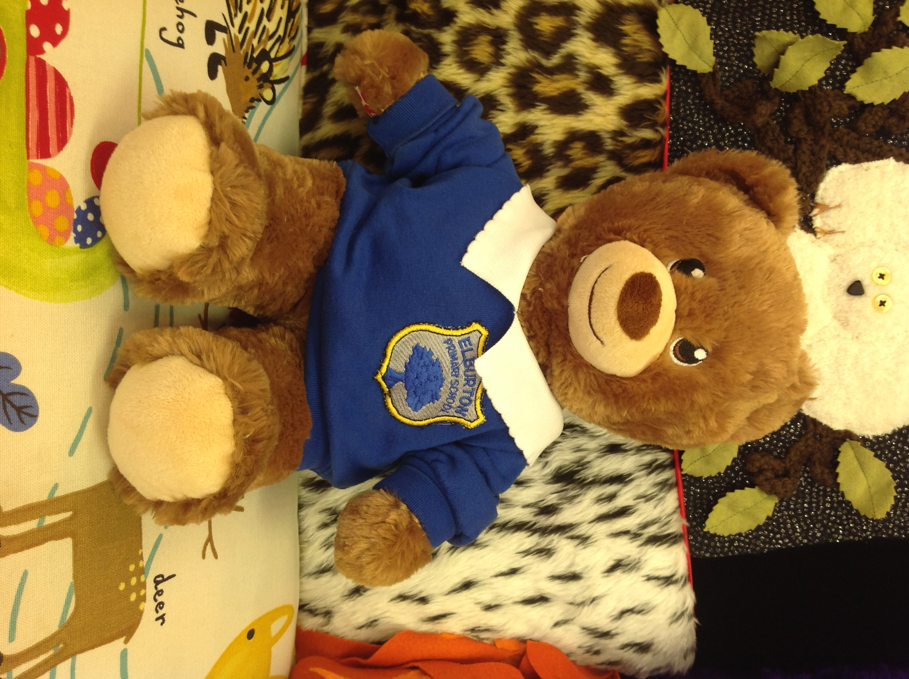
Hello,

My name is Johnny!

I am very cuddly and friendly. I love going on adventures, visiting new places and meeting new people. I get very tired after a busy day at school and playing with my friends. At bedtime I like to have a story and a big hug before I go to sleep.

Can you draw or write about our adventures in my diary so we can show your friends? Please remember to bring me back to school so that someone else can take me home.

Love from

Johnny the Bear

Dear Parents/Carers,

Johnny is our class teddy bear! It is your childs turn to take Johnny home.

Johnny has a diary in which we would like your child to record Johnny’s adventures! Your child might like to take some photos, draw some pictures, or write in the diary about what they did with Johnny (this might be pretend writing or supported, emergent writing where letters are recognisable.) Whilst your child will need some support to record in Johnny’s diary, please encourage them to have a go independently (we are more than happy to just receive a drawing/photo of Johnny and some “pretend” writing!) Each time Johnny returns to class, we will share the diary entries.

Please could you ensure that your child returns Johnny to school on the Monday so that another child can take him home the following Friday.

Have fun!

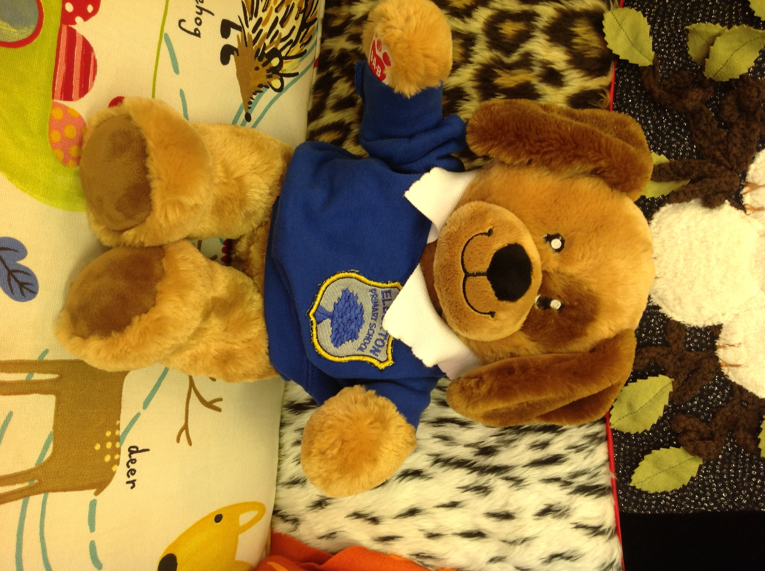
Hello,

My name is Sparkle!

I am very cuddly and friendly. I love going on adventures, visiting new places and meeting new people. I get very tired after a busy day at school and playing with my friends. At bedtime I like to have a story and a big hug before I go to sleep.

Can you draw or write about our adventures in my diary so we can show your friends? Please remember to bring me back to school so that someone else can take me home.

Love from

Sparkle the Bear

Dear Parents/Carers,

Sparkle is our class teddy bear! It is your childs turn to take Sparkle home.

Sparkle has a diary in which we would like your child to record Sparkle’s adventures! Your child might like to take some photos, draw some pictures, or write in the diary about what they did with Sparkle (this might be pretend writing or supported, emergent writing where letters are recognisable.) Whilst your child will need some support to record in Sparkle’s diary, please encourage them to have a go independently (we are more than happy to just receive a drawing/photo of Sparkle and some “pretend” writing!) Each time Sparkle returns to class, we will share the diary entries.

Please could you ensure that your child returns Sparkle to school on the Monday so that another child can take him home the following Friday.

Have fun!

