Wednesday 22nd May 2024
Personal, Social, Health and Relationship Education
‘Changing Me’
Dear parents/carers,
This year, we have continued to implement the Jigsaw PSHRE (Personal, Social, Health and Relationship Education) programme across our school. The lessons that your child has taken part in through the year have built their emotional literacy, self-esteem and knowledge of who they are and how they relate to each other and the world in a positive and healthy way.
The Summer Term Puzzles (units) are about Relationships (unit 1) and Changing Me (unit 2) and they cover all areas of statutory requirements for the delivery of health and relationships education which all schools are required to follow. Further information regarding these requirements can be found on the DfE website https://www.gov.uk/government/publications/relationships-education-relationships-and-sex-education-rse-and-health-education/relationships-education-primary
As a school, we believe that knowledge empowers and protects children as long as it is age appropriate. The Changing Me Puzzle includes, in every year group, two or three lessons to help children understand the changes puberty brings and how human reproduction happens. There is a very serious safeguarding aspect to this work; obviously, the younger year groups are not looking at these issues directly and explicitly, but rather learning correct terminology for body parts and doing the foundation work for learning that will follow in later year groups. Puberty is introduced gently in Y3 because some girls may start their periods this early and it is necessary to prepare them for this, so they aren’t scared or worried. Conception is introduced age-appropriately in Y4 in the context of understanding why our bodies change during puberty. Understanding of Human Reproduction, conception and puberty is built upon in Year 5 and then puberty, conception and childbirth is age-appropriately covered in Y6. In the table below, you can see a summary in respect to what is taught relating to Puberty (in black) and Human reproduction (in red).
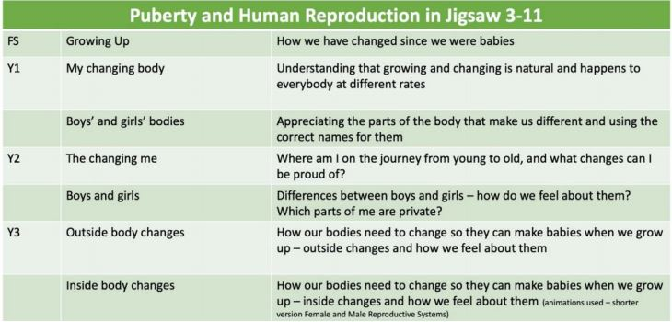

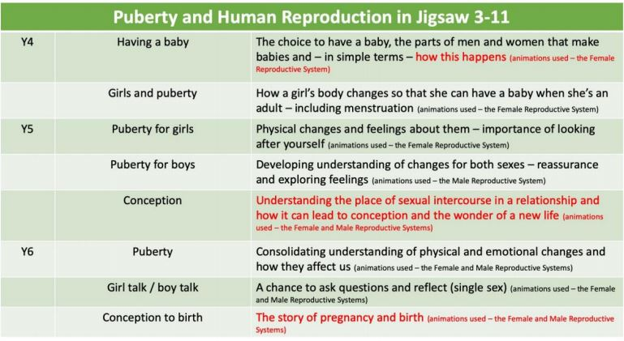
Where parents/carers once had the choice to remove their child from all Sex Education lessons each year, following updated statutory guidance for Health and Relationships Education that came into place in September 2020, the vast majority of what is now required of schools is statutory and must be taught to all pupils. This content is covered in black in the table above. You cannot withdraw your child from Relationships and Health Education because it is statutory and incredibly important that all children receive this content, covering topics such as friendships, positive relationships and how to stay safe.
Parents/carers do have the right to withdraw their child/children from any lessons which cover Human Reproduction, and this content is shown in red in the table above. However, we do, as always, want to work in partnership with parents and carers and we hope that you, like us, will see the materials in Jigsaw as educationally sound and beneficial to our children. It is also important to consider that the teaching of Sex Education is statutory from Year 7 and these lessons provide a carefully structured introduction, in an age-appropriate way. These sessions will be taught by Class Teachers and supporting adults that are familiar to the children in each class as we are aware that there is some sensitive content in these units.
Should you have any concerns or queries about the teaching content of this unit, please feel free to contact me via 01752 404489 or at keith.smithers@horizonmat.com
Kind regards,
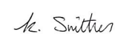
Keith Smithers
Head Teacher

