PHYSICAL EDUCATION AT ELBURTON PRIMARY SCHOOL
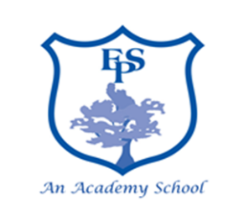


Our P.E curriculum promotes physical activity, health and wellbeing. We encourage pupils to be active for sustained periods of time and excel in a broad range of sports. Our competitive activities promote teamwork, communication, motivation and achievement.

P.E lessons are sequenced so they build upon previous learning, children re-visit skills over time so they become competent and develop a love for a sport.
The school invests in a PE specialist to support teachers and team teach PE lessons across the school.
Children in EYFS revise and refine fundamental movement skills which lay the foundations for KS1.

Children compete and learn the values of competition in lessons, Sports Day and interschool competitions.

EFFECTIVE LEARNING IN PHYSICAL EDUCATION
New skills are modelled and broken down using small steps. The STEP process is used to support children in being successful with these new skills, and to deepen their learning.

Units of learning finish with a competitive element so children develop a positive sense of competitive spirit. KS2 take part in level 1 (intraschool) competitions.

Specialist swimming instructors teach year 4 children how to swim and provide CPD for staff. All year groups receive swimming provision in our outdoor swimming pool.

SEND pupils are fully included in all lessons and adaptions are made using the STEP process so they can always access the learning.
Children come to school wearing their PE kit so no time is wasted in lessons getting changed.

Year 5 Play Leaders and MTA’s are provided with training to encourage active playtimes.

