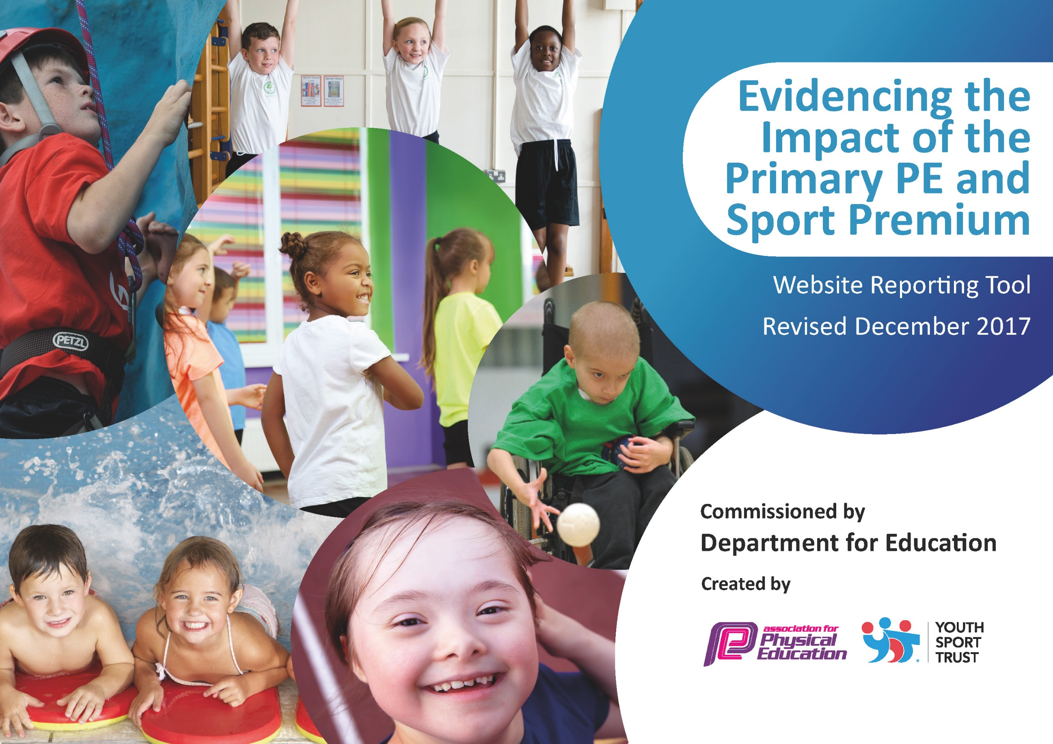

Schools must use the funding to make additional and sustainable improvements to the quality of PE and sport they offer. This means that you should use the Primary PE and Sport Premium to:

- develop or add to the PE and sport activities that your school already offers
- build capacity and capability within the school to ensure that improvements made now will benefit pupils joining the school in future years

Please visit gov.uk for the revised DfE guidance including the 5 key indicators across which schools should demonstrate an improvement. This document will help you to review your provision and to report your spend. DfE encourages schools to use this template as an effective way of meeting the reporting requirements of the Primary PE and Sport Premium.

We recommend you start by reflecting on the impact of current provision and reviewing the previous spend.
Under the Ofsted Schools Inspection Framework, inspectors will assess how effectively leaders use
the Primary PE and Sport Premium and measure its impact on outcomes for pupils, and how effectively governors hold them to account
for this.

Schools are required to publish details of how they spend this funding as well as on the impact it has on pupils’ PE
and sport participation and attainment.
We recommend regularly updating the table and
publishing it on your website as evidence
of your ongoing review into how you are using the money
to secure maximum, sustainable impact. To see an example of how to complete the table please click HERE.

Support for review and reflection - considering the 5 key indicators from DfE, what development needs are a priority for your setting and your students now and why? Use the space below to reflect on previous spend, identify current need and priorities for the future.

Key achievements to date: | Areas for further improvement and baseline evidence of need:
Gymnastics CPD for FS, KS1 and KS2 teachers  Increase in competitive Sports through level 1 and level 2 competitions  Increased intake of after-school clubs for KS1 and KS2  Platinum Kitemark Awarded October 2017 | Staff PE audit revealed lack in confidence from FS and KS1 teachers in the teaching of PE.  Staff audit revealed that KS2 teachers would like more support with outdoor games.  Increase and promote physical activity during lunchtimes  Swimming CPD required for all teachers (3 yearly update)

Meeting national curriculum requirements for swimming and water safety | Please complete all of the below*:
What percentage of your current Year 6 cohort swim competently, confidently and proficiently over a distance of at least 25 metres? | 96.6%
What percentage of your current Year 6 cohort use a range of strokes effectively [for example, front crawl, backstroke and breaststroke]? | 96.6%
What percentage of your current Year 6 cohort perform safe self-rescue in different water-based situations? | 100 %
Schools can choose to use the Primary PE and Sport Premium to provide additional provision for swimming but this must be for activity over and above the national curriculum requirements. Have you used it in this way? | No
*Schools may wish to provide this information in April, just before the publication deadline.

Action Plan and Budget Tracking
Capture your intended annual spend against the 5 key indicators. Clarify the success criteria and evidence of impact that you intend to measure to evaluate for students today and for the future.

Academic Year: 2018/19 | Total fund allocated: £19,780 | Date Updated:17/10/2018
Key indicator 1: The engagement of all pupils in regular physical activity – Chief Medical Officer guidelines recommend that primary school children undertake at least 30 minutes of physical activity a day in school |  |  |  | Percentage of total allocation:
 |  |  |  | 7.58 %
School focus with clarity on intended impact on pupils: | Actions to achieve: | Funding allocated: | Evidence and impact: | Sustainability and suggested next steps:
MTA training to increase children’s physical activity to at least 30 minutes a day. | Key MTA’s to be trained to lead and manage lunchtime activities with KS1 and KS2. (Children from the leadership club can also support this) | £1,500 | - Increasing the number of children taking part in physical activity during lunchtimes. | MTA’s increased knowledge of leading physical games will continue throughout children’s time at Elburton. Children will continue to actively participate in games during their lunchtimes through the encouragement of MTA’s and the leadership club  Next steps: MTA’s to support Year 5 Play Leaders to run lunchtime activities.
Key indicator 2: The profile of PE and sport being raised across the school as a tool for whole school improvement |  |  |  | Percentage of total allocation:
 |  |  |  | 2.43 %
School focus with clarity on intended impact on pupils: | Actions to achieve: | Funding allocated: | Evidence and impact: | Sustainability and suggested next steps:
A broad and balanced PE curriculum/engagement in various levels of competition/celebration of participation. | - Write comprehensive development plans.  - Monitor the planning and delivery of PE  - Organise CPD  - Maintain the School Games Mark expectations and collate all necessary evidence | £480 | - Improving the quality of the PE experience of students  - Development plans  - Lesson observation and feedback notes  - Programme of CPD opportunities  - School Games Mark Evidence and Award | Knowledge and experience of PE lead will ensure that we are able to maintain comprehensive action plans, re-use existing formats for vital documents and templates for letters home etc.  Next Steps:  In order to target the Platinum award more time may be required in order to collate evidence and complete the case study required for the additional requirement of the application process.  The hiring of a PE apprentice would also help to support the evidencing of the Kitemark.

Key indicator 3: Increased confidence, knowledge and skills of all staff in teaching PE and sport |  |  |  | Percentage of total allocation:
 |  |  |  | 66.85 %
School focus with clarity on intended  impact on pupils: | Actions to achieve: | Funding  allocated: | Evidence and impact: | Sustainability and suggested  next steps:
Positively impact learning in PE | PSSP employed to deliver bespoke CPD sessions for KS2 teachers.  Attend primary PE conference and access regular INSET’s provided. | £3500 | Feedback forms completed by all staff on completion of 1:1 CPD. Continued professional development for PE lead as well as wider school staff. Up-to-date relevant resources employed by staff to deliver PE. Increased confidence levels will positively impact teaching and learning | Investing in staff is a priority as this will be our most sustainable resource. Staff confidence and knowledge will benefit all children in years to come. Continued affiliation with the PSSP will mean that we can access ongoing CPD and support.  Next Steps: Continue to work alongside PSSP to deliver bespoke CPD lessons for those teachers that did not receive this in 2018/2019
Positively impact learning in PE | Premier Sports  Qualified coaches to work with FS and KS1 teachers, developing their knowledge and skills in school sports. | £7956 | Continued professional development for PE lead as well as FS and KS1 teachers will build confidence and support a broad and balanced curriculum, impacting teaching and learning. | Investing in staff is a priority as this will be our most sustainable resource. Staff confidence and knowledge will benefit all children in years to come. Continued affiliation with Premier Sport will mean that we can access ongoing CPD and support.  Next Steps: Teachers to now use new knowledge and skills learnt to plan and teach own lessons. Offer YST resources to help support this.
Positively impact learning in PE | Youth Sport Trust to provide staff with PE resource cards to support the planning and teaching of PE.  Athlete mentor visit to be arranged. | £1,100 | Resource cards will provide teachers with new ideas when teaching PE.  Athlete mentor visit will inspire and enthuse young children to continue/start physical activity. | PE Co-ordinator met with expert development manager. Next Steps: Make use of resource cards in school and arrange an INSET with YST  Athlete mentor visit will inspire children to continue physical activity beyond primary school. NB: this is planned for Sept/Oct 2019
Positively impact learning in PE | Swimming INSET  TA water safety & first aid training. | £250.00  £416.00 | Swimming CPD for teachers will build confidence of teaching swimming, impacting children’s learning.  Poolside safety training for TAs will allow teaching sessions to take place safely and efficiently. | Wendy Dalton ran a twilight inset to train all staff in poolside first aid and suggested lesson formats. This provided support for all staff prior to using the pool throughout the summer term. This allowed us to continue to use the pool safely and also incorporated TA poolside safety training which is now incorporated into every lesson.
Key indicator 4: Broader experience of a range of sports and activities offered to all pupils |  |  |  | Percentage of total allocation:
 |  |  |  | 23.14 %
School focus with clarity on intended  impact on pupils: | Actions to achieve: | Funding  allocated: | Evidence and impact: | Sustainability and suggested  next steps:
Introduce new sports activities encouraging more pupils to take up to be involved in physical activity.  Targeted at pupils with low self-esteem/weaker sports skills/reluctance to participate | Premier Sports  Including after-school and lunchtime activities.  Set up a leadership club for children to run and lead their own lunchtime club for future sustainability.  Set up a Change for Life Club to promote physical activity, health and wellbeing for targeted pupils.  After – school clubs (partly grant funded and partly parental funded) to promote a wide range of sports (including alternative sports such as Ultimate Frisbee) and increase participation for KS1 and KS2. | £3432 | Increasing participation in after school activities to year groups who in the past were not able to participate.  Increase confidence and build self-esteem to specific children – the hope is that these children then have the courage and confidence to take part in more physical activity (with MTA’s in lunchtime or by taking part in an after-school club) | KS1&2 after school clubs to continue with Premier Sport to encourage ALL children to participate in physical education.  Play leaders (year 5) used to support/run lunchtime sporting activities alongside MTAs.  PE apprentice used to provide Change for Life club opportunities during lunch times for targeted children.
To ensure PE resources provide impact on learning | PE equipment  -Reinstate football goals to school field (half of field was used last year for the KS2 build)  -Audit current equipment and purchase any new equipment needed to support the teaching and learning of PE | £1,145.26 | All required equipment is ready to be utilised during PE sessions and in a good state of repair. | Autumn Term Priorities:  Reinstate football goals to school field.  -Audit current equipment and purchase any new equipment needed to support the teaching and learning of PE.
To provide children with the opportunity to build confidence in swimming | Hire a swimming Life guard 2x weekly for after-school club. | £0.00 | Additional swimming sessions will give children the opportunity to build their confidence and enjoyment. | As part of our TA pool side safety training, an after-school TA was utilised to support after-school swimming.
Key indicator 5: Increased participation in competitive sport |  |  |  | Percentage of total allocation:
 |  |  |  | 0 %
School focus with clarity on intended  impact on pupils: | Actions to achieve: | Funding  allocated: | Evidence and impact: | Sustainability and suggested  next steps:
Increase the number of competitive opportunities for children of all abilities and age groups. | Annual membership to the PSSP: target events offered by the PSSP to provide children of all age groups and abilities with the opportunity to compete. | *PSSP cost in KI3 | PSSP provide termly reports on the number of events attended. PE Coordinator will monitor engagement of all children throughout the year. | Continued affiliation to the PSSP will ensure we are able to access a broad range of events and competitions. Positive experiences will likely lead to life-long participants.
Where necessary, hire transport. | Hire a minibus for events where we do not have enough support for the transport to and from the venue. | £0.00 | Increased participation of Level 2 competitions through PSSP | Through hiring transport, more children will have the opportunity to attend Level 2 events across the city.  Note: the hire of transport has not been necessary.

