Dear Parents in Classes 6EM and 6PA Spring 2019

Firstly, we would like to start by thanking you for all your support during last term and Happy New Year to you all! We do appreciate the amount of time you put into helping children at home – both in terms of guidance with the homework, but also in getting children into an organised routine to ensure they have the things they need at the right time.

The weekly routine this until half term will be:
- PE and Games kit Tuesday or Wednesday and Friday

Homework - both Classes
- Maths given out Monday - collected Thursday
- English given out and set Thursday - collected Monday and spellings tested

Regular opportunities for the children to read a wider range of materials at home are very helpful in continuing to broaden children’s knowledge of literature. During this term, our main aim is to cover all the remaining aspects of English and Maths in preparation for the SATs tests.

This term you will have the opportunity to come into the classroom and share some of the work your child has been doing - the date will be Tuesday 26th March 2019.

The main elements of this term’s work will be:
- English: Daily spelling and grammar will take place in line with the SATs tests. The children will be doing comprehension every Friday as well as regular reading within school.
- Maths: Again this term there will be emphasis on reasoning as well as arithmetic and formal algorithms. We will be continuing use and recall of multiplication facts – number bonds and exploring the variety of mental strategies available when problem solving.
- Science: Evolution and Adaptation, Classification
- Geography: South America
- PE: Dance and Indoor Rowing (Led by specialist coaches)
- Games: Invictus and Orienteering
- French: The children will continue to be taught French each week for half of the whole term. A specialist teacher will come in to deliver this.

DATES
- Tuesday 15th January 2019 - Class photos. For this we ask children to bring in one object to pose with.
- The actual SATs will take place 13th - 17th May 2019 inclusive.

As before, we will contact you if we have specific concerns about your child. Please do contact us if you have any queries.

Yours sincerely

Miss Marriott Mr P Agnew
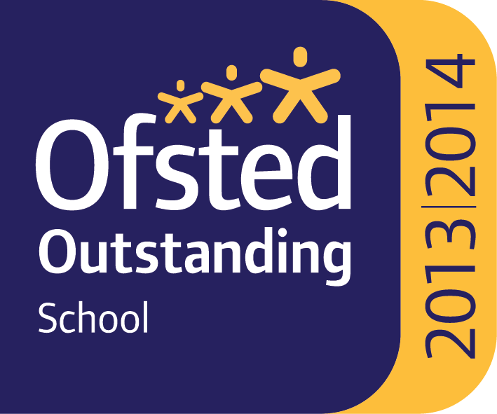
Class 6EM Class 6PA

