

Schools must use the funding to make additional and sustainable improvements to the quality of PE and sport they offer. This means that you should use the Primary PE and Sport Premium to:

- develop or add to the PE and sport activities that your school already offers
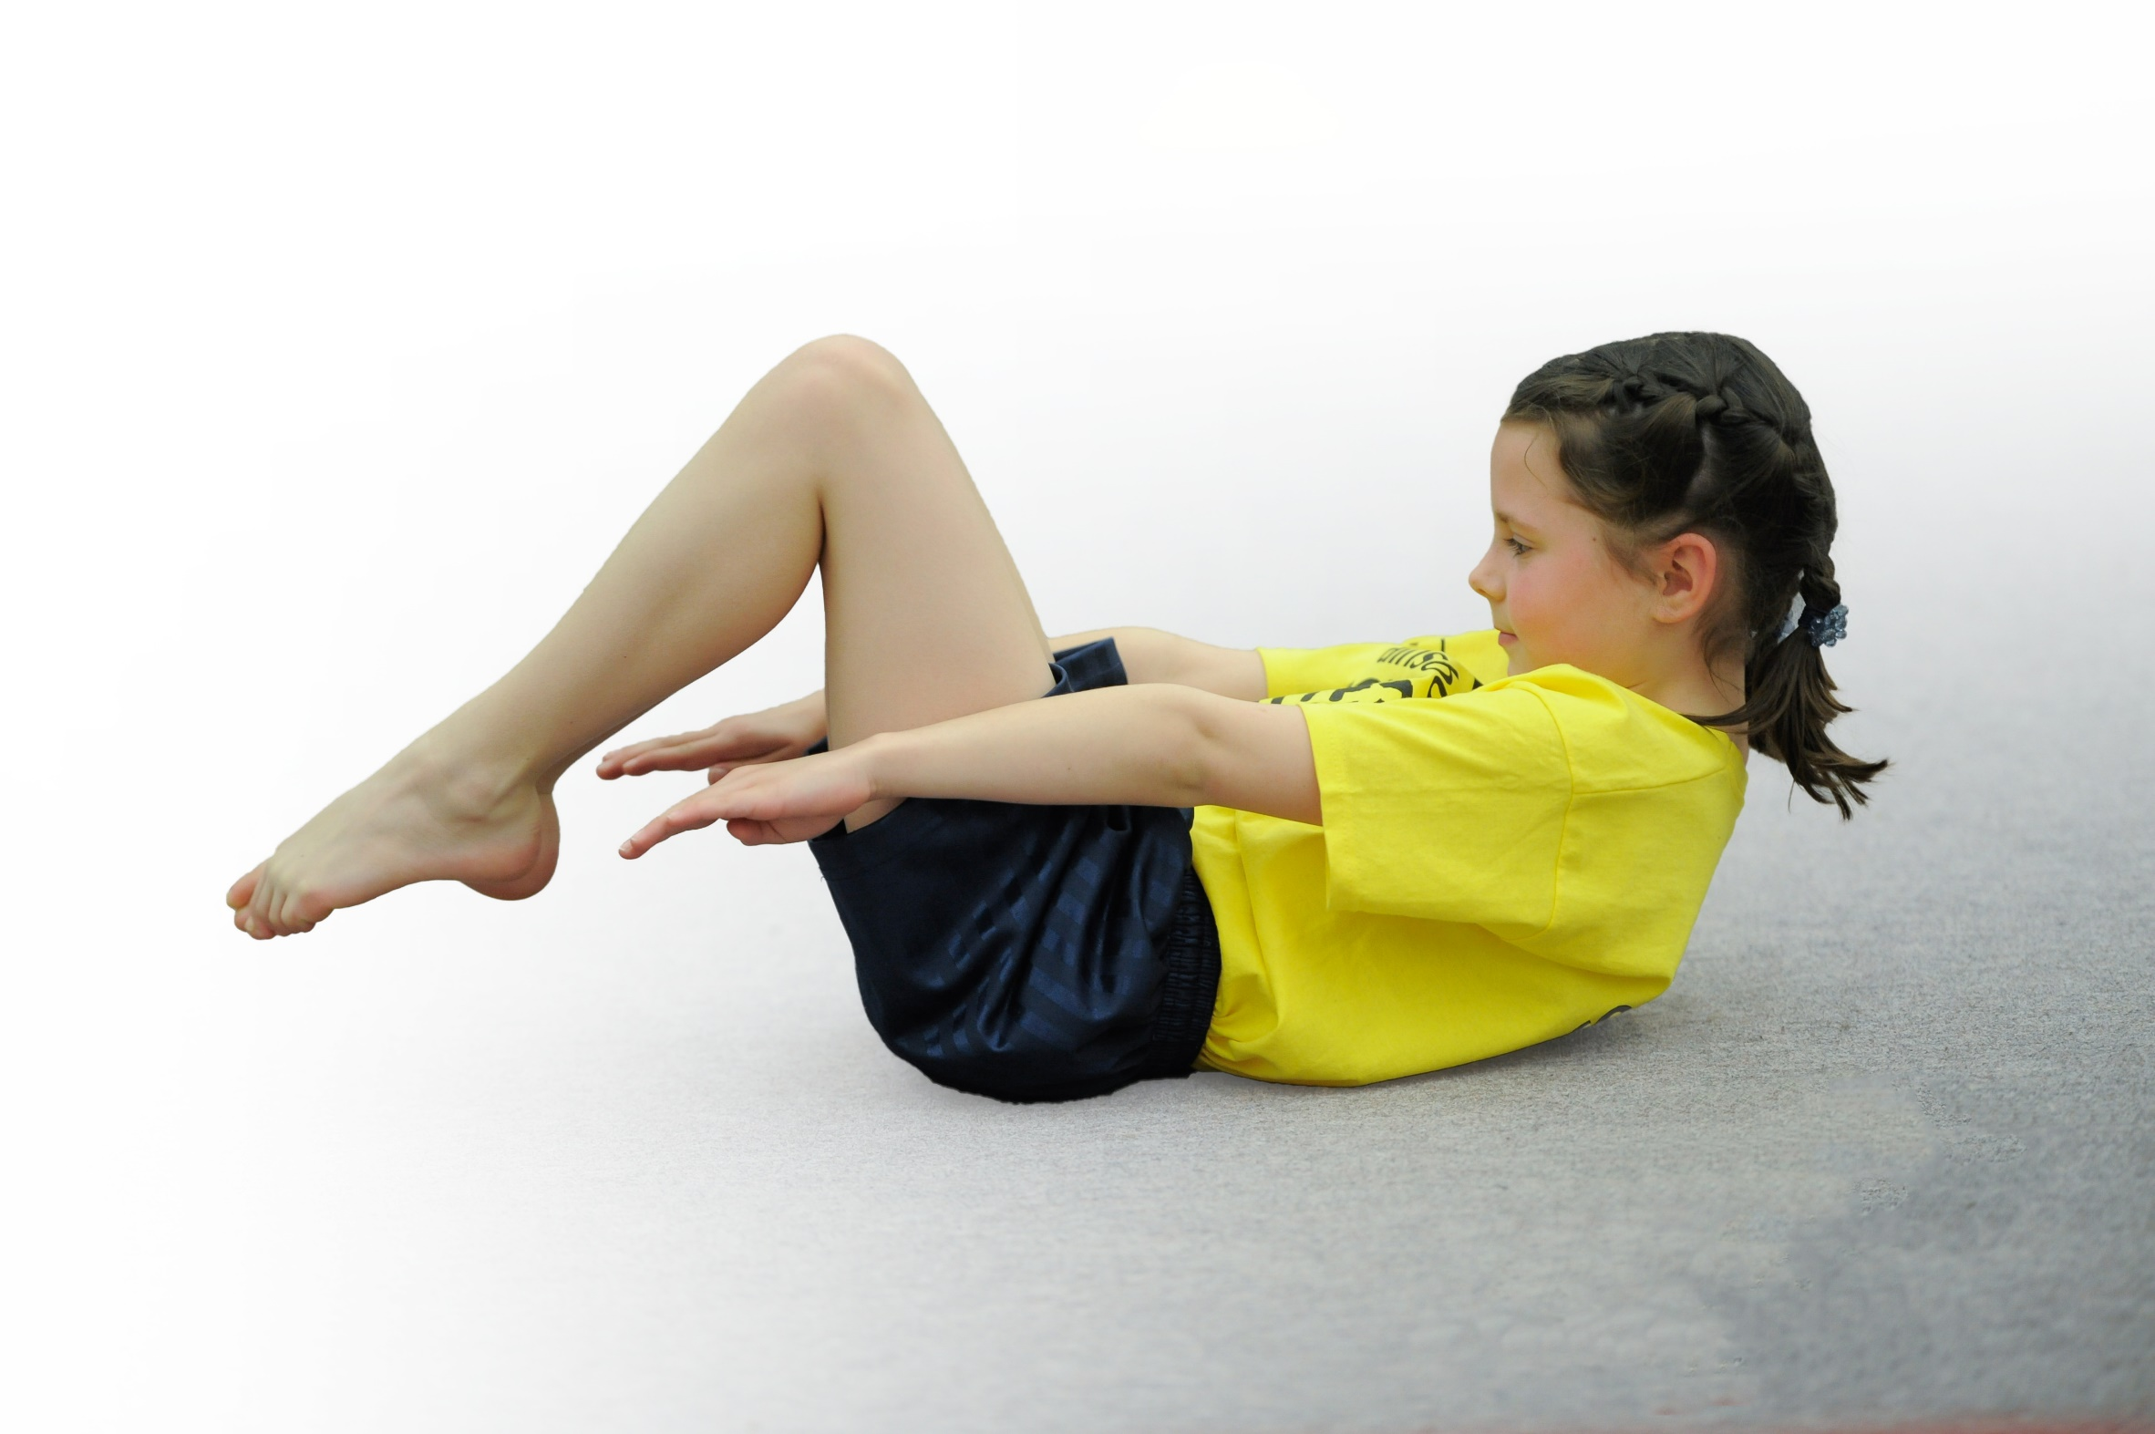
- build capacity and capability within the school to ensure that improvements made now will benefit pupils joining the school in future years

Please visit gov.uk for the revised DfE guidance including the 5 key indicators across which schools should demonstrate an improvement. This document will help you to review your provision and to report your spend. DfE encourages schools to use this template as an effective way of meeting the reporting requirements of the Primary PE and Sport Premium.

We recommend you start by reflecting on the impact of current provision and reviewing the previous spend.
Under the Ofsted Schools Inspection Framework, inspectors will assess how effectively leaders use
the Primary PE and Sport Premium and measure its impact on outcomes for pupils, and how effectively governors hold them to account
for this.

Schools are required to publish details of how they spend this funding as well as on the impact it has on pupils’ PE
and sport participation and attainment.
We recommend regularly updating the table and
publishing it on your website as evidence
of your ongoing review into how you are using the money
to secure maximum, sustainable impact. To see an example of how to complete the table please click HERE.

Support for review and reflection - considering the 5 key indicators from DfE, what development needs are a priority for your setting and your students now and why? Use the space below to reflect on previous spend, identify current need and priorities for the future.

Key achievements to date: | Areas for further improvement and baseline evidence of need:
2018/2019  Trained lifeguards in school to support teachers in swimming lessons  Swimming CPD for all teachers  CPD for FS and KS1 by Premier Sports  2017/2018  Gymnastics CPD for FS, KS1 and KS2 teachers  Increase in competitive Sports through level 1 and level 2 competitions  Increased intake of after-school clubs for KS1 and KS2  Platinum Kitemark Awarded October 2017 | Engaging all pupils to be active 30 minutes every day  Inspire young girls to be active and have a passion for sport  Curriculum support in the planning and teaching of PE  Inspire all children to improve in sports through focusing on personal best

Meeting national curriculum requirements for swimming and water safety (2018-2019)  Swimming did not take place 2019-2020 due to school closure | Please complete all of the below*:
What percentage of your current Year 6 cohort swim competently, confidently and proficiently over a distance of at least 25 metres? | 96.6%
What percentage of your current Year 6 cohort use a range of strokes effectively [for example, front crawl, backstroke and breaststroke]? | 96.6%
What percentage of your current Year 6 cohort perform safe self-rescue in different water-based situations? | 100 %
Schools can choose to use the Primary PE and Sport Premium to provide additional provision for swimming but this must be for activity over and above the national curriculum requirements. Have you used it in this way? | No

Action Plan and Budget Tracking
Capture your intended annual spend against the 5 key indicators. Clarify the success criteria and evidence of impact that you intend to measure to evaluate for students today and for the future.

Academic Year: 2019/20 | Total fund allocated: £19,780 | Date Updated: September 2019
Key indicator 1: The engagement of all pupils in regular physical activity – Chief Medical Officer guidelines recommend that primary school children undertake at least 30 minutes of physical activity a day in school |  |  |  | Percentage of total allocation:
 |  |  |  | 2.5%
School focus with clarity on intended impact on pupils: | Actions to achieve: | Funding allocated: | Evidence and impact: | Sustainability and suggested next steps:
MTA training and Year 5 play leader training to increase children’s physical activity to at least 30 minutes a day. | Key MTA’s and Play Leaders to be trained to lead and manage lunchtime activities with KS1 and KS2. | Part of PSSP see KI3 | - Increasing the number of children taking part in physical activity during lunchtimes.  Impact: Year 5 play leaders were fully trained and organised games for infants, including targeted pupils. This increased the number of children taking part in physical activity and improved children;s behaviour. | MTA’s increased knowledge of leading physical games will continue throughout children’s time at Elburton. Children will continue to actively participate in games during their lunchtimes through the encouragement of MTA’s and the leadership club.
Provide Equipment boxes for KS1 and KS2 to use at lunchtime, encouraging all to be more active. | School Council to choose equipment they would like in the boxes. Play Leaders to organise the equipment daily. | £500  Actual: £381 | Increasing the number of children taking part in physical activity during lunchtimes.  Impact: Equipment was being used in the spring term before school closure. More children were encouraged to play physical activities at lunchtime. This equipment was also used by Play Leaders. | New equipment will encourage pupils to play more games and be active at lunchtime. Play Leaders will be able to use this equipment to lead and plan games, teaching children who could be future play leaders.
Key indicator 2: The profile of PE and sport being raised across the school as a tool for whole school improvement |  |  |  | Percentage of total allocation:
 |  |  |  | 23.2%
School focus with clarity on intended impact on pupils: | Actions to achieve: | Funding allocated: | Evidence and impact: | Sustainability and suggested next steps:
Time for PE lead to organize and manage PE throughout the school  A broad and balanced PE curriculum/engagement in various levels of competition/celebration of participation. | - Write comprehensive development plans.  - Monitor the planning and delivery of PE  - Organise CPD  - Maintain the School Games Mark expectations and collate all necessary evidence  - Liaise with KS1 PE co-ordinator and PE Apprentice | £600 for 6 mornings  Actual:£1,148 | - Improving the quality of the PE experience of students  - Development plans  - Lesson observation and feedback notes  - Programme of CPD opportunities  - School Games Mark Evidence and Award  Impact: NJ attended full day of REAL PE training for CPD. REAL PE was then shared with staff and is now being used across the school.  Termly meetings were spent to liais with the PE apprentice, liaise with the admin team and organise events each half term.  Kitemark on hold until 2020-2021  Lesson observations were dues to take place in the summer term. | Knowledge and experience of PE lead will ensure that we are able to maintain comprehensive action plans, re-use existing formats for vital documents and templates for letters home etc.
- Hire a PE Apprentice to support the development and provision of PE and sports. | - Support teachers for PE and games in the afternoons.  - Support PE Co-ordinator:  -Auditing and organising equipment  -Evidencing for Kitemark, e.g. displays, photographs, social media etc.  - Run a Change for Life Club during lunchtimes  - Support staff organising events and attend some of the PSSP events. | £3000  Actual £6208 | - Improving the quality of the PE experience of students  - School Games Mark Evidence and Award  - Change for Life club that is sustainable  - Increase participation in Level 2 events; attend more Level 2 events  Impact: PE apprentice was trained in taking a small group for Change for Life Club. This took place every Monday lunchtime. Children were allowed to bring a friend to the club which gave a higher percentage of attendance.  The apprentice supported class teachers in the delivery of games, and supported targeted children with fundamental skills and agility, balance and co-ordination skills.  PE Apprentice audited and organised the PE shed and hall equipment on a regular basis, and helped to complet PE displays to celebrate children’s sporting achievements. | Apprentice was available to take children to events locally to support increase in participation for level 2 events.
- Hire an admin assistant to be responsible for the organisation of letters and registers for sporting clubs and events | - Support PE lead in writing letters for clubs  - Support PE lead with admin for level 2 and 3 competitions  - Collate registers to track participation and for parent pay for any clubs | £1000 | - Improving the organization of PE in line with OfSTED and school gamesmark  - School Games Mark Evidence and Award  - Track and increase participation in Level 2 events; attend more Level 2 events | Impact: efficient organisation of events and clubs placed on ParentPay enabled a clear indication of participation of level 2 events and after-school sports clubs.

Key indicator 3: Increased confidence, knowledge and skills of all staff in teaching PE and sport |  |  |  | Percentage of total allocation:
 |  |  |  | 36.8%
School focus with clarity on intended  impact on pupils: | Actions to achieve: | Funding  allocated: | Evidence and impact: | Sustainability and suggested  next steps:
Positively impact learning in PE | PSSP employed to deliver bespoke CPD sessions for KS2 teachers.  Attend primary PE conference and access regular INSET’s provided. | £3500 | Continued professional development for PE lead as well as wider school staff. Up-to-date relevant resources employed by staff to deliver PE. Play leaders with Year 5 to support younger children at lunchtimes. Increased confidence levels will positively impact teaching and learning  Play leaders training took place.  Coach delivered lessons to KS1 and KS2 where teachers were encouraged to team teach alongside the coach to support CPD. (See PSSP impact report) | Investing in staff is a priority as this will be our most sustainable resource. Staff confidence and knowledge will benefit all children in years to come. Continued affiliation with the PSSP will mean that we can access ongoing CPD and support.
Positively impact learning in PE | Youth Sport Trust to provide staff with PE resource cards to support the planning and teaching of PE.  Athlete mentor visit to be arranged. | £1,100  Actual: £1,100 | Resource cards will provide teachers with new ideas when teaching PE.  Athlete mentor visit will inspire and enthuse young children to continue/start physical activity.  Mentor visit took place in Autumn with a rowing olympic medalist, focusing on ‘determination’ and ‘personal best’. She rean an assembly and workshops. | Athlete mentor visit will inspire children to continue physical activity beyond primary school.  We were due to have another mentor visit but this was cancelled due to school closure.
Positively impact learning in PE | REAL PE CPD Twilight and one session per teacher for coaching | £2695  (£2195 | All teachers will be trained in REAL PE so that they are confident in following the scheme. Using REAL PE will ensure for continuity across the school. | REAL PE is now being taught across the school (FS-Y6). Staff enjoyed the training and were enthused to put it into practice.  Next step: To refine the assessment of REAL PE across the school. Possible school-based support (team teach) from REAL PE coaches in the Summer term for staff?
Key indicator 4: Broader experience of a range of sports and activities offered to all pupils |  |  |  | Percentage of total allocation:
 |  |  |  | 36.2%
School focus with clarity on intended  impact on pupils: | Actions to achieve: | Funding  allocated: | Evidence and impact: | Sustainability and suggested  next steps:
Introduce new sports activities encouraging more pupils to take up to be involved in physical activity | Change4Life with PSSP coach to support PE apprentice | £180  (to begin in November) | Reluctant pupils more willing to take part in regular PE and engaging in inter school activities  Impact: C4L club took place across two terms weekly during lunchtimes with targeted KS2 pupils. The children had planned to attend a C4L club which was cancelled due to covid | Having a PE apprentice take on the role of C4L lead will ensure the club is embedded for the future.
Introduce new sports activities encouraging more pupils to take up to be involved in physical activity | Premier Sports after-school club for KS1 and KS2  Introduce a football club to KS1 as this has not been offered before at Elburton  KS2 offer of alternative sports, such as fencing and ultimate Frisbee. | £116 per week = approximately £4000 (- approx. £2000 from parental support)  Actual: £8,684 was spent in total on external coaches, including for PSSP coaches. | Increasing participation in after school activities to year groups who in the past were not able to participate  Impact: Increased participation for KS1 pupils (after-school clubs) for first half of year. Football club took place across three half-terms due to such high interest.  Premier Sports worked with Educare pupils weekly during school closures. Dure to school closures, we had no parental support for the payment of Premier Sports from April –July. | Display of clubs available to pupils in area  Celebrate participation in sport through whole school assembly presentations.  Increased participation for KS1 pupils for first half of year.  Premier Sports worked with Educare pupils weekly during school closures.
To ensure PE resources provide impact on learning | PE equipment  -Audit current equipment and purchase any new equipment needed to support the teaching and learning of PE | £1000-2000  (dependent on Premier Sports)  Actual ? | Staff can teach the curriculum with the necessary resources, and inspire children with new equipment/games. | Equipment was ordered for some of the REAL PE units – teachers have access to the unit trunk so the resources are readily available to them. More will need to be ordered in the next budget.
To ensure playground equipment promotes and encourages children to be active throughout breaktimes and lunchtimes. | Reinstate the trim trail | £3000  Not completed due to other costs (coaches and apprentices) | All Children will have the opportunity to explore and play on the trim trail. Each year group will have set days and times for this and they will be encouraged by MTA’s to use it.  Teachers will make use of the trim trail between lessons to increase children’s activity time (30 minutes per day outside PE curriculum time) | Increased physical exercise by all.  The trim trail has always been so widely used. Refurbishing the trim trail will encourage and enthuse children to be more active in their own time. Consider this for next year.
To provide children with the opportunity to build confidence in swimming | Hire a swimming Life guard 2x weekly for after-school club.  Ensure currently lifeguards have up-to-date training/train more life guards to support teachers in swimming lessons? | £500  This did not take place due to school closures. | Additional swimming sessions will give children the opportunity to build their confidence and enjoyment.  This did not take place due to school closures. | Not needed due to school closure (used to cover Premier Sports additional costs as there were no parental costs during the school closure).  Staff will need to be retrained next year.
Key indicator 5: Increased participation in competitive sport |  |  |  | Percentage of total allocation:
 |  |  |  | 2.5%
School focus with clarity on intended  impact on pupils: | Actions to achieve: | Funding  allocated: | Evidence and impact: | Sustainability and suggested  next steps:
Increase the number of competitive opportunities for children of all abilities and age groups. | Annual membership to the PSSP: target events offered by the PSSP to provide children of all age groups and abilities with the opportunity to compete. | *PSSP cost in KI3 | PSSP provide termly reports on the number of events attended. PE Coordinator will monitor engagement of all children throughout the year.  A number of Level 2 events were attended by KS2 in terms 1 - 4. (See PSSP impact report) | Continued affiliation to the PSSP will ensure we are able to access a broad range of events and competitions. Positive experiences will likely lead to life-long participants.
Where necessary, hire transport and supply to allow teachers to attend supporting events with high volume of pupils attending. | Hire a minibus for events where we do not have enough support for the transport to and from the venue.  Book supply (when necessary) to allow teachers to attend events | £150  Did not happen  £350  Actual £539 | Increased participation of Level 2 competitions through PSSP  Teachers were able to attend sporting events, such as cross country to support large groups children attending level 2 competitions. | Through hiring transport, more children will have the opportunity to attend Level 2 events across the city. NB. This will only be used in the event where we do not have enough parent support.

