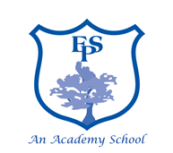

Meal Time Assistant – Elburton Primary School

6.25 hrs per week / 38 weeks per year Scale: Grade A
Horizon MAT are seeking to appoint a hardworking, enthusiastic and committed MTA to join our dedicated team at Elburton Primary School. The successful candidate must be:
- Reliable, cheerful and motivated individual who is able to work as part of a team
- Supervise pupils during their lunch break
- Promote the school’s effective behaviour policy
- Supervise train and motivate their team as required
- Ability to communicate at all levels
Our School and all its personnel are committed to safeguarding and promoting the welfare of the children. This post is subject to an Enhanced Disclosure Application to the Disclosure and Barring Service.
For full details contact Helen Sherriff email admin.elburton@elburton.plymouth.sch.uk
Closing Date: Friday 4th December 2020 8am Interview Date: Monday 7th December 2020

