**100 Books To Read In Year 5 and 6**

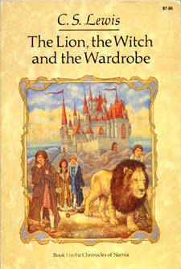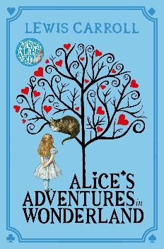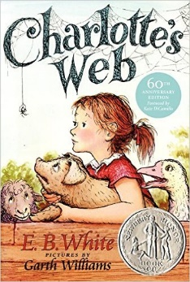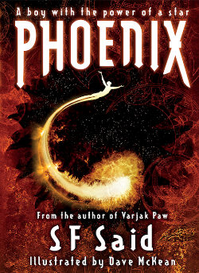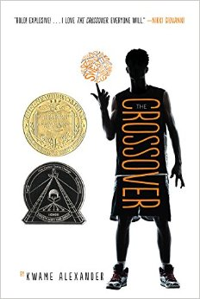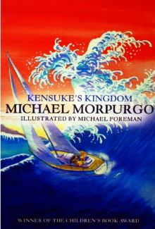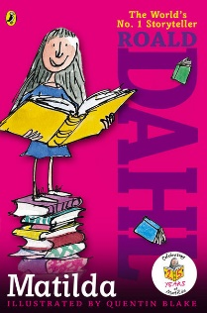

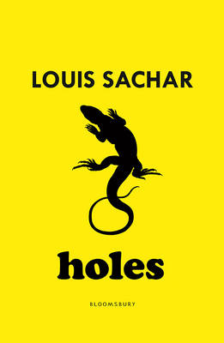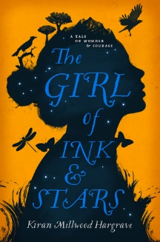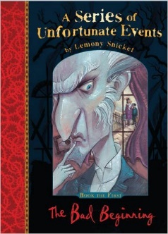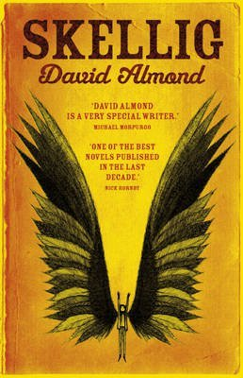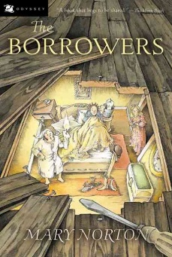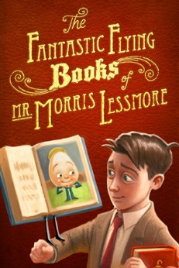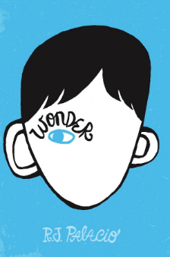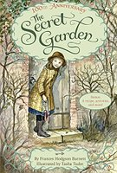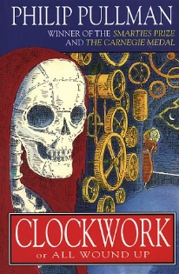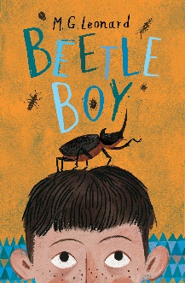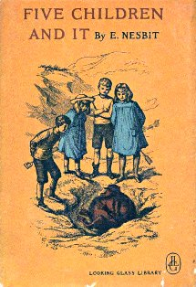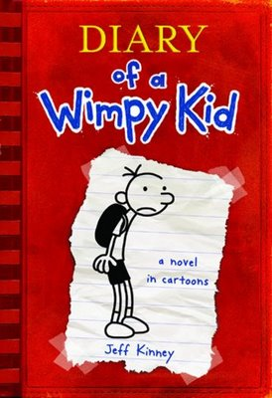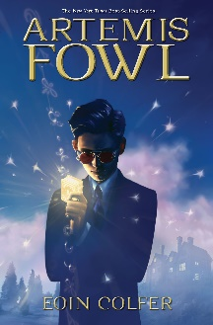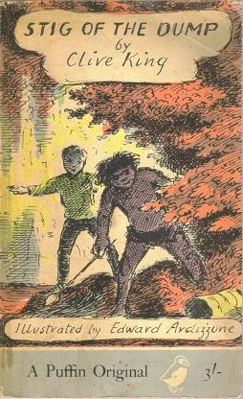

Holes

Louis Sachar

The Girl of Ink and Stars

Kiran Millwood Hargraves

A Series of Unfortunate Events

Lemony Snickett

Skellig

David Almond

The Fantastic Flying Books of Mr Morris Lessmore

William Joyce

The Borrowers

Mary Norton

Wonder  
RJ Palacio

The Crossover

Kwame Alexander

The Secret Garden

Frances Hodgson Burnett

Clockwork

Phillip Pullman

Beetle Boy

M G Leonard

Five Children and It

E Nesbit

Diary Of A Wimp Kid

Jeff Kinney

Artemis Fowl

Eoin Colfer

Stig Of The Dump

Clive King

The Lion, The Witch and The Wardrobe

C S Lewis

Alice’s Adventures In Wonderland

Lewis Carroll

Charlotte’s Web

E B White

Phoenix

S F Said

Kensuke’s Kingdom

Michael Morpurgo

Matilda  
Roald Dahl