‘All about me’
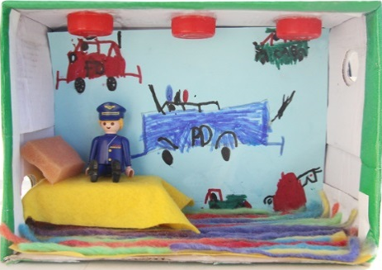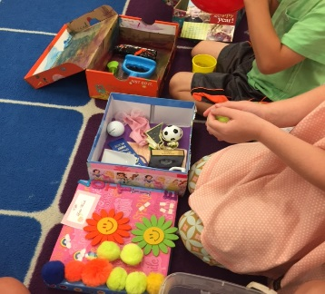
During the first few weeks of term we encourage the children to grow in confidence and share information about themselves. Over the holidays we would like the children to create an ‘all about me’ shoebox, you may wish to use the children’s school shoe box!
Please support your child to decorate their box to represent their personality, show off any skills they are proud of, highlight any hobbies that they may enjoy and of course it may be nice to include photos of close friends and family.
These all about me boxes will form the first display in your child’s classroom as well as becoming a lovely discussion resource.

Thank you and we look forward to sharing them with you,
The Foundation Team.

