The rationale behind the Foundation Team’s focus upon self-regulation was first brought to our attention when we read an article by Kathy Sylva : The Role of Families and pre-school in educational disadvantage, 2014. It argued that a potential difference between the achievement of children from a range of socio-economic backgrounds was partly due to lower levels of executive function. It suggested that high quality early years’ provision should nurture executive function in children. Further reading by Alexandra Marie Volckaert: Trends in Neuroscience and Education, 2015 suggests there are four aspects of inhibitory control that we need to have to manage daily interactions and circumstances.
- Interruption of an on-going response
- Impulsivity control
- Inhibition of predominant response
- Inhibition of external distractions
Elburton Primary School has been part of a team of teachers and researchers that have been thinking about how to support children in managing these skills. This has involved ‘in the moment’ teaching when situations arise and also specific skills teaching at other calmer times. As part of this skills teaching we have used these four characters whom your child may have already have started to talk about with you which represent these four ideas stated above. The children have been asking to have pictures of these to use at home and so in response to this we have created this booklet to give you a bit more information about how you could use these characters and support your child in their personal, social and emotional development.

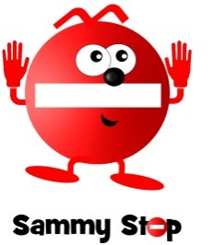
The story of Sammy Stop
New Girl Nel loved having shiny things. She was like a magpie. Whenever she saw something she liked she would just take it and add it to her collection. One day Nel saw her friend making a picture. Her friend added some shiny sequins to her creation. Nel wanted them. All of them. Nel stretched out her hand towards her friend’s picture when… down swung Sammy Stop! Sammy said,
“Stop! Think. Are you making a good choice?” Sammy asked Nel “Who do they belong to? Who is using them?” Nel realised that taking them from her friend’s picture was the wrong thing to do. She stopped, thought and decided to...

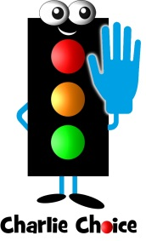
The story of Charlie Choice
New Girl Nel was playing in the mud kitchen. She was making a lovely muddy soup. Her friend had the same idea and he tipped all of the water into his saucepan. There was none left for Nel. Nel began to feel hot. She felt her hands tighten up into balls and her face scrunched up into her angry look. Her feelings grew and grew and grew until she thought she might burst, when… down swung Charlie Choice! Charlie said
“Stop. Think! You have a choice! There is another way”
Charlie said “I can see that you are feeling like you could burst. You have a choice. You could burst or you can think of another way. Go to the tap. Ask your friend to go to the tap. Change the recipe…” They thought through the options and then made a choice that kept everyone happy.

The story of Dani Driver
Dani Driver was driving along when he saw New Boy Nick. Nick was looking hot and bothered. His face was red and his hands were scrunched. Nick was stood at the edge of the playground. He was glaring at the children on the bikes. He did not have one but his sister did. It was not fair. He wanted a go on one. He wanted a go on one now! As his sister cycled past, Nick pulled out his arm, ready to push her off of her bike, when… in zoomed Dani Driver who said, “Stop. Think! You are about to make a wrong choice! Steer your brain to make a better choice!” Nick considered his choices and made his brain change direction to make a better choice that ensured everyone was happy.

The Story of Freddie Focus
New Boy Nick was about to write the best story he had ever written in his whole life. It was full of magic and mayhem. It was a lovely sunny day. The windows were open and outside Nick could hear some children playing. It sounded like fun. He wondered if he could listen and join their game. He put down his pencil and started to peer out of the window, when… down swung Freddie Focus! Freddie said, “Stop! Think! You have a choice! Focus your mind”
Freddie said “You can get distracted. You can listen to them or you can focus your mind on the main thing - your story!”

Vocabulary to use to help your child make good choices and calm down:
Stop
Think
Calm
Breathe
I’m listening
Use your words
Let’s go to your calm place (could be an actual place or in imagination, could be an activity they find calming e.g. colouring, music).
Explain what happened from your point of view
Think. What do you need to do?
You are heading towards a wrong choice; you need to turn your behaviour around. (Link to Dani Driver).
Ideas for skill development:
Children can be trained to go to a physical place or to do a physical activity in the home/school when they recognise they are feeling close to an outburst or wrong choice.
Children might not be able to verbalise what has happened or how they are feeling when in proximity to an outburst or having just had an outburst. You might need them to calm down first before you discuss a situation. Be aware that bringing up the situation again can ‘re-fuel’ the original feelings.
They might need you to talk about what you see in them (i.e. feelings, physical reactions) or what has happened, as long as you know, ‘I can see that you…’ Inaccurate commentary about a situation could make it worse.
Use made up stories that teach about a character who is facing a similar situation to one that caused upset for your child. Sometimes it is easier to think about what someone else should do rather than themselves e.g. stories enclosed here about New Girl Nel and New Boy Nick. It will take time to move from KNOWING what choice should have been made after an event to MAKING the right choice and following it in the ‘heat of the moment’.
Make them aware of how their body is feeling so they can begin to recognise the signs, e.g. clenched fists, feeling hot, tears, increased heart rate.
Affirm and praise when making a good choice and link back to this in a situation where a choice needs to be made to encourage the right choice and remind them that they can do it. You could keep a book or photos of ‘successful moments’.
Model sharing, turn taking, waiting for something you want in games with your child and talk out loud about your feelings and how you are managing yourself.

Developing skills for
self-regulation
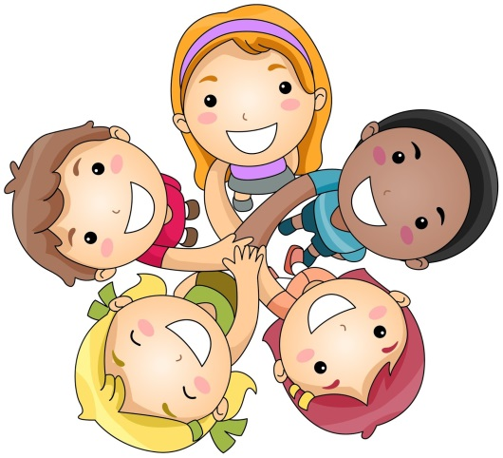
Executive function in young children
Supporting the development of inhibitory control.

