***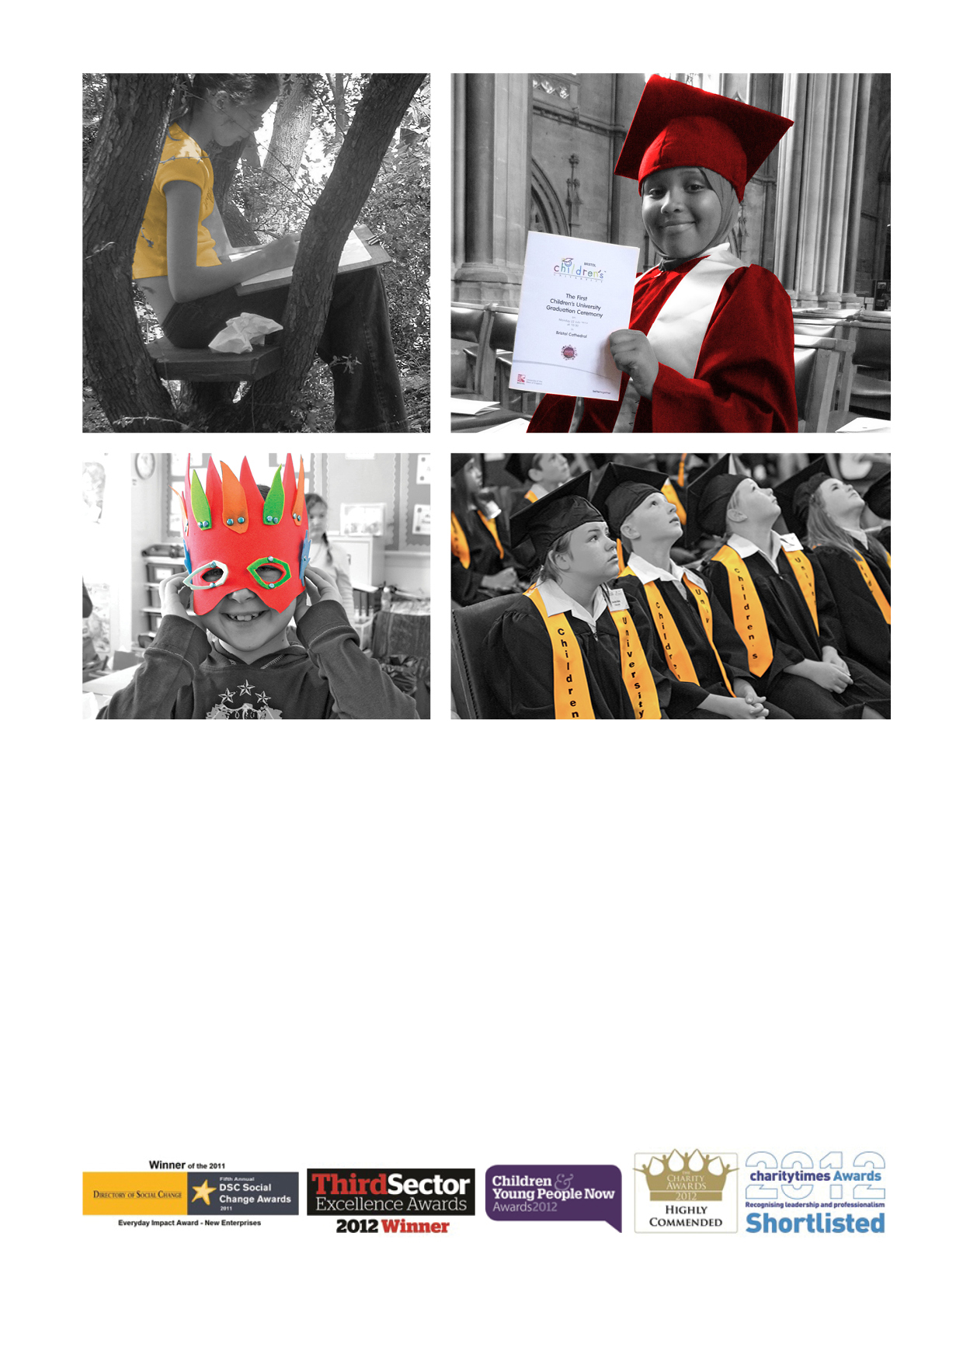******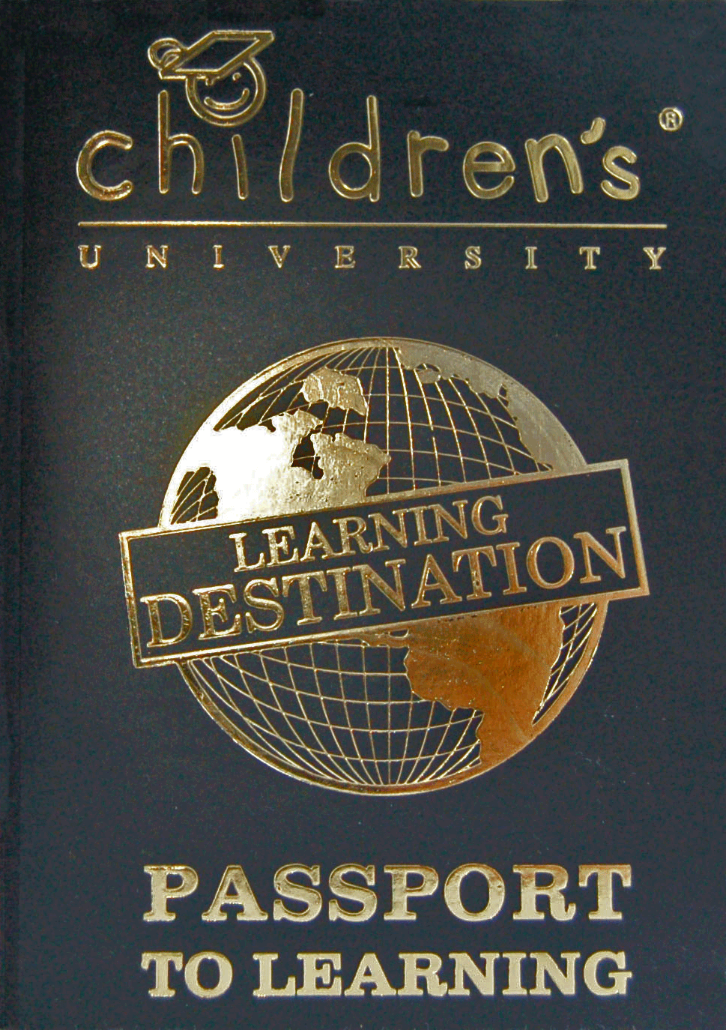***

**Why do I need a *Passport To Learning*?**Your *Passport To Learning* shows that you are a member of the Children’s University™. You can use your *Passport To Learning* torecord all of the CU Learning Activities that you take part in at CU *Learning Destinations.*

**Where can I use my *Passport To Learning*?**

Some of the hours you collect will be for CU *Learning Activities* you do at school and some of the hours you collect will be for visits to Public CU *Learning Destinations*. Most CU *Learning Destinations* display our *Learning Destination* sticker or poster. Remember, you can only use your *Passport To Learning* at CU *Learning Destinations*. You can find details of Public *Learning Destinations* on our website.

**Why do I need to use my *Passport To Learning?***You use your *Passport To Learning* to collect evidence of the hours of learning you have completed whilst working towards a CU Certificate. Once you have reached bronze, silver or gold an adult will need to contact us on your behalf and register your hours and we will prepare your certificate. These will be presented at a CU Graduation Ceremony.

**What is the back of my *Passport To Learning* for?**

This part of your *Passport To Learning* is for you to record your ‘Moments to be Proud Of’ – this is where you can show-and-tell what you have enjoyed most on your Children’s University learning journey.

**What if I have filled up fill my *Passport To Learning*?**When your *Passport To Learning* is full, speak to your school who will arrange for a new one to be issued to you. There is a cost for the *Passport To Learning* of £3.

**What happens if I lose my *Passport To Learning?***If you have lost your *Passport To Learning, please c*ontact us and let us know.

**Can I nominate a CU *Learning Destination*?**Yes. If you go somewhere you think should be a CU *Learning Destination* please get in touch with us

Tel: 01752 307455

Email: [carol.henwood@plymouth.gov.uk](mailto:carol.henwood@plymouth.gov.uk)

Website: [www.thechildrensuniversity.co.uk](http://www.thechildrensuniversity.co.uk)

**Info for children…**

**A guide to using your *Passport To Learning***

**How do I collect hours in my *Passport To Learning?***

Take your *Passport To Learning* with you to each CU *Learning Activity* you attend. The activity leader will fill in your *Passport To Learning* to show you have taken part.

|  |  |  |  |
| --- | --- | --- | --- |
| DATE | HOUR(S) | ACTIVITY | STAMP OF APPROVAL |
| **1/5/13** | **2** | **CU Lecture** |  |
| **4/5/13** | **1** | **After School Cookery** |  |

**How many hours do I need for a CU Certificate?**

If you look inside your *Passport To Learning*, you will see that you can work through lots of CU Award levels. Starting with your Bronze Award for 30 hours of CU Activities, up to your Gold Fellowship Award for 1,000 hours. Your 30 hours Bronze Award can be awarded for one or more activities but after that you should have at least 5 hours of learning something new for the Silver level and then 10 hours of something new for your Gold and all other Awards over 100 hours.