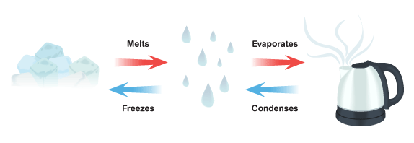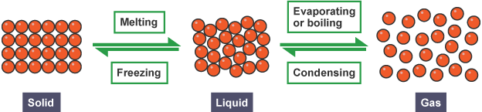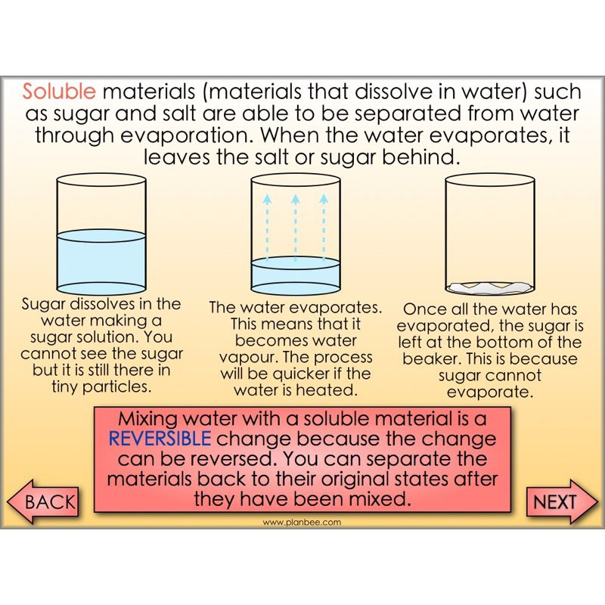

**Key Vocabulary**

**Conductor – A material or device which allows heat or electricity to carry through**

**Dissolve – When something solid mixes with a liquid and becomes part of the liquid**

**Evaporation – The process of turning from liquid to vapour**

**Flexible – Capable of bending easily without breaking**

**Gas – An air-like fluid substance which expands freely to fill any space available**

**Insulator – A substance which does not readily allow the passage of heat or sound**

**Irreversible – Cannot be reversed back to its original state**

**Liquid – A substance that flows freely but can be measured by volume e.g. water or oil**

**Magnetic – Capabale of being magnetised or attracted by a magnet**

**Material – The matter from which a thing is or can be made from**

**Opaque – Not able to be seen through, not transparent**

**Reversible – Able to be reversed back to its original state**

**Solid – Firm and stable in shape, not a liquid or fluid**

**Soluble – Able to be dissolved, especially in water**

**Thermal – Relating to heat**

**Transparent – Allows light to pass through so that objects behind can be seen**

**Materials**