Elburton Primary School Pupil Premium Strategy Statement 2019-2022
- Summary information
School | Elburton Primary School Amendments of 3 year plan in blue 2019/2020
Academic Year | 2020-21 | Total PP budget 2020-2021 | £70,510 | Publish Date | October 2020
Total number of pupils | 426 | Number of pupils eligible for PP | 72 (16.9%)  (Ever 6 10 pupils - 2.4%  Free School Meals 25 pupils - 5.9%  LAC/PLAC 5 pupils - 1.2%  Service 32 pupils – 7.5%) | Date for next review of this strategy | July 2021
Statement Authorised by: | Keith Smithers (Acting Head teacher) and the Local Governing Body
Pupil Premium Lead: | Sarah Lakey (Assistant Head teacher/SENCO)
Governor Lead: | Carolyn Haynes

- Attainment and Progress 2019 % 2020 based on Teacher Assessment
Year 6 pupils | Pupils eligible for PP | All Pupils National Averages (school all pupils) | Progress Score for Pupils eligible for PP
% achieving expected standard or above in reading, writing & maths | 78% 89% | Expected or above 65% (school 71% 79%) | NA  The DfE will not be publishing any school or college level educational performance data based on tests, assessments or exams for 2020.
Reading | 78% 100% | Expected or above 73% (school 75% 89%) | -1.3 (National: -0.6, School: 0.9)
Writing | 89% 100% | Expected or above 78% (school 93% 87%) | 1.94 (National: -0.4, School: 2.4 )
Maths | 89% 89% | Expected or above 79% (school 90% 87%) | 2.6 (National: -0.6, School: 2.6 )

- Barriers to future attainment (for pupils eligible for PP, including high ability)
In-school barriers
 | Low levels of oracy skills and limited vocabulary.
 | Poor reading fluency leading to lack of stamina and comprehension skills.
C. | Maths mastery: fluency, problem solving and reasoning.
D. | Social, emotional, mental health difficulties related to ACEs (Adverse Childhood Experiences) or attachment difficulties.
E. | Poor effective behaviour for learning strategies including self-regulation and meta-cognition.
External barriers (issues which also require action outside school, such as low attendance rates)
F. | PP Attendance lower than non-PP. September – November 2020 - Whole School – 96.57% Pupil Premium - 96.78%

- Strategy Aims for Disadvantaged Pupils
3 Year Plan | 2019-2022 (reviewed annually) September 2020 review
The three headings below enable schools to demonstrate how they are using the pupil premium to improve classroom pedagogy, provide targeted support and support whole school strategies.
- Quality of TEACHING for all
Aim | Target |  | Activity |  |  | Target Date
A  Progress in oracy and vocabulary. | All children speak in compete sentences.  All children in Foundation access cued articulation.  All children access and use word of the day upper tiered words in sentences. |  | Whole school approach to speaking in sentences.  CPD – oracy, word of the day and cued articulation.  Daily teaching of word of the day Tier 3 words.  Progression of taught technical and subject specific vocabulary across broad and engaging curriculum subjects. |  |  | September 2021  Implemented through 19/20  Embed and monitor 20/21
B  Progress in reading fluency and comprehension. | Achieve above 92% in Phonics in Year 1 (92% 2019). Achieve above last year’s percentage for PP pupils. (60% 2019)  All Year 2 retake Phonics will pass.  Achieve above national average progress score in reading to be above 2 (0.9, 2019) |  | a) Ensure all staff (all teachers and Foundation/KS1 and 1:1 TAs + train new staff) attend and receive Read Write Inc Training to deliver phonics scheme consistently and effectively. Continued CPD and development days over 2019-2020 and coaching 2020-2021 to ensure RWI is embedded.  b) High emphasis on reading for pleasure, daily story time, love of reading culture, community reading events such as Race for Reading, Favourite Five and author visits.  CPD to improve reading teaching, whole class reading and comprehension strategies such as ERIC and VIPERS.  c) Buy and embed us of Accelerated Reader across key stage 2 to increase reading for pleasure, comprehension and used as a diagnostic assessment tool to inform teaching.  Ensuring all staff use evidence-based whole-class teaching approaches/interventions. |  |  | September 2021  Await Nov 2020 results  September 2020  Continue to embed  September 2021  In place and purchased for Year 2
C  Progress in Maths. | Achieve above national average progress score in maths to be above 2.5. |  | Continue to work with Maths hub and CPD to embed Teaching For Mastery across all year groups from Foundation – Year 6. Embed use of live marking and on the day maths surgeries to address misconceptions.  Continue CPD for new staff.  Raise the profile of small steps and mastery approach through whole school working walls.  Ensuring all staff use evidence-based whole-class teaching approaches/interventions. |  |  | September 2021
D & E  A whole school and consistent approach to class/school routines and expectations through PACE, metacognition and regulation strategies. | To reduce class disruption – evidenced on CPOMs.  Evidence of self-regulated learners. |  | a) Whole School Jigsaw PSHE curriculum.  b) Whole school effective behaviours policy with links to displays, regulation characters and universal use of language of behaviour and regulation.  c) Embed CPD and PACE training across whole school context.  d) Use EEF Meta-cognition handbook in CPD.  e) Healthy Schools Award  f) Mental Health Award  g) Trauma Aware Award |  |  | September 2020 Implemented  September 2020  Implemented  September 2020  Implemented  September 2021  September 2020  September 2021  September 2022
Projected Spending: |  |  |  |  | £11,500 RWI + £4000 Acc Reader + £1000 High interest books
- Targeted support for current academic year:
Measure |  | Activity
Teacher led interventions: |  | Daily Maths surgeries for on the day feedback and addressing misconceptions.  Writing conferencing.  Phonics ‘Pinny Time’ or 1:1 tuition.  Using Catch Up Premium – employment of Reading Recovery teacher and Teacher in Y1/2 (see Catch Up Premium plan)
Teaching Assistant led interventions: |  | BLAST/SPIRALS/Talkboost to improve speech, language and vocabulary outcomes.  Maths surgery 1:1 and small group for disadvantaged pupils falling behind ARE.  Precision Instruction – for disadvantaged children falling behind in reading and spelling.  Phonics 1:1 tuition and ‘Pinny Time’ for disadvantaged at risk of not passing Y1 phonics.
After school club: |  | Y6 Booster club for disadvantaged pupils falling behind in reading and maths. Prevented due to Covid.
Barriers to learning these priorities address |  | Closing the gap through ‘keep-up’ rather than ‘catch up’ ensuring that the gap is not too wide.
Projected Spending: |  |  |  | £3000 Phonics development days , MAST intervention training costs £400, TA overtime for booster club £120
- Wider Strategies for current academic year:
Measure |  |  | Activity
Engaging curriculum to raise cultural capital. |  |  | CPD and implementation of Chris Quigley approach to broad and engaging curriculum to increase cultural capital for disadvantaged pupils. Developed bespoke curriculum for Elburton locality using Rising Stars.
Free breakfast |  |  | Access to free breakfast club provision for disadvantaged pupils. Implemented
Improving social interaction and maintaining attachments/relationships. |  |  | Use of individualised Social stories and Social/Communication groups such as Circle of Friends and Socially Speaking to improve social interaction, friendships and social understanding. Implemented
Enrichment offer. |  |  | Increase in enrichment offer through clubs, visits and music tuition entitlement for disadvantaged pupils to increase cultural capital. Implemented
Bespoke clubs. |  |  | Provision of bespoke clubs to meet individual needs: Implemented but on hold due to COVID restrictions  Military Club Kids Resilience Boost Young Carers club Well-being club
Multi-Agency Support |  |  | Buy in to MAST (Multi-Agency Support Team) for increased provision such as Therapist, Learning Mentor, Counsellor to support individuals and families with acute need. Implemented
Improve PP attendance in-line with school target of 95.5%. |  |  | Admin to monitor attendances and follow up absences on the same day.  EWO support - ½ termly attendance meetings (admin, HT and PSA). Implemented
Barriers to learning these priorities address |  |  | Raising cultural capital, improving attendance and readiness to learn for disadvantaged pupils.
Projected Spending: |  |  |  |  | £1,300 Chris Quigley Training and resources, £8,000 MAST buy in, proportion of PSA role £22,000, proportion of SENCO/Inclusion role £10,000, £800 for tuition and trips

5. Monitoring and Implementation:
Area | Challenge | Mitigating Action
Teaching | Ensuring enough time is given for training and following up monitoring/coaching. | Use of INSET days and additional cover being provided by supply/SCITT student time.
Targeted Support | Ensuring enough time for English/Maths leads to monitor and coach.  Ensuring all interventions are value for money, evidenced based and making an impact. | SCITT student’s time used to free up English/Maths lead. Extra staff INSET time allocated.  Only using evidenced based interventions and all interventions to have in/out assessment.
Wider Strategies | Engaging the children and families facing the most challenges. Ensuring school and home partnership is built. | Working closely with PSA to engage parents through workshops, coffee mornings and including them in planning meetings.

6. Review: Last year’s aims and outcomes.
Aim | Outcome
Language skills in Reception and KS1 are lower for pupils eligible for PP than for other pupils. | Cued Articulation Training received by all teaching staff. Talkboost and Spirals intervention staff coaching/mentoring across Foundation and KS1. Foundation TA mentored/coached by Speech and Language Therapy Service. KS1 staff trained in Colourful Semantics language intervention.  SALT cases closed and support given in school. Steady improvement in disadvantaged pupil progress from 2018-2019.  Interventions now need to embed.
PP pupils working at greater depth in maths, reading and writing at the end of both Key Stages. | 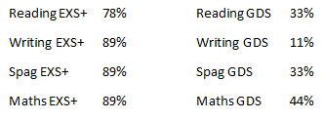
Pupils deemed to be disadvantaged in Reading, Writing and Maths are not ALL achieving age related expectations of attainment in ALL year groups. | At the end of KS1, PP pupils were not all attaining ARE but made progress. By end of KS2, most PP pupils made expected progress and attainment.
Pupils’ mental Health and wellbeing. | Training delivered in PACE, attachment and JIGSAW (PSHE).  There are now less ELSA TAs in each Key Stage than before. Training and buy into MAST (Multi Agency Support Team) for next year to address SEMH needs.
Pupils who are deemed eligible for pupil premium (ever 6, formerly LAC and CLA) who have additional specific barriers to their learning

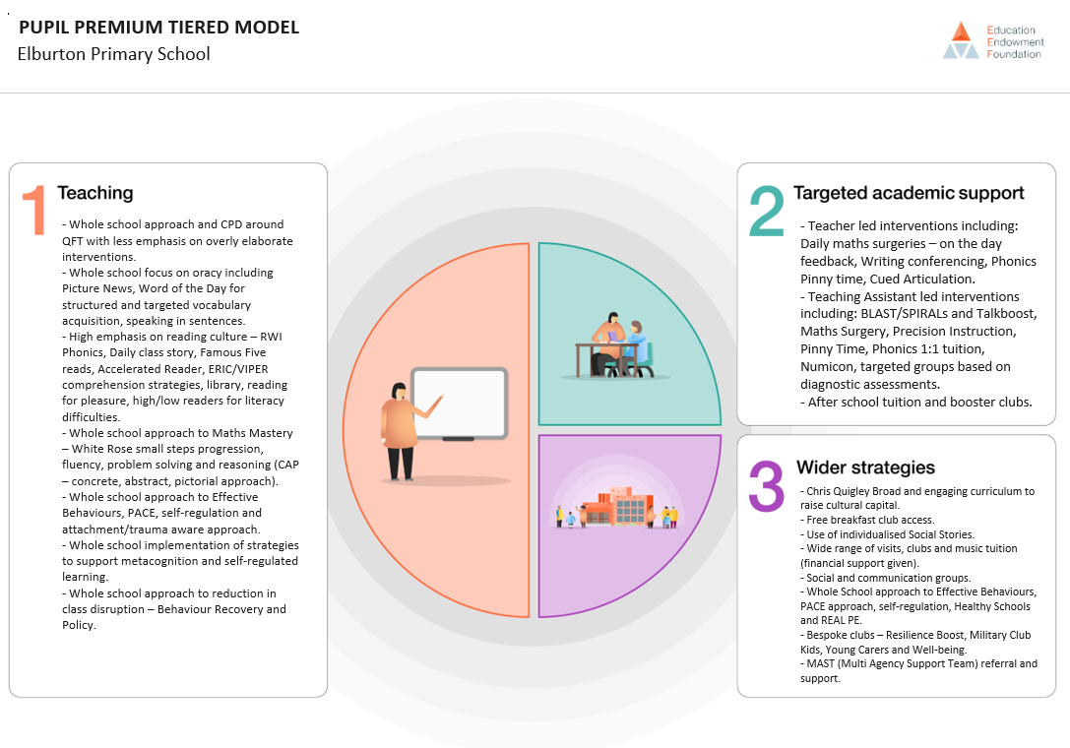

Appendix Data – 2019-2020
Year 6 Pupils  (Based on  Spring Term Assessment) | Pupils Eligible for PP  (9) | PP+  (0) | School All Pupils  (62) | All Pupils National Average (KS2 2019)
% achieving expected standard or above in reading, writing & maths | 89% | - | 79% | 65%
Reading | 100% | - | 89% | 73%
Writing | 100% | - | 87% | 78%
Math | 89% | - | 87% | 79%
Year 5 Pupils  (Based on  Summer Term Assessment) | Pupils Eligible for PP  (14) | PP+  (3) | School All Pupils  (60) | All Pupils National Average (KS2 2019)
% achieving expected standard or above in reading, writing & maths | 71% | 67% | 68% | 65%
Reading | 79% | 67% | 83% | 73%
Writing | 79% | 67% | 73% | 78%
Math | 71% | 67% | 75% | 79%
Year 4 Pupils  (Based on  Summer Term Assessment) | Pupils Eligible for PP  (13) | PP+  (0) | School All Pupils  (62) | All Pupils National Average (KS2 2019)
% achieving expected standard or above in reading, writing & maths | 62% | - | 74% | 65%
Reading | 92% | - | 87% | 73%
Writing | 77% | - | 79% | 78%
Math | 69% | - | 84% | 79%
Year 3 Pupils  (Based on  Sumer Term Assessment) | Pupils Eligible for PP  (13) | PP+  (0) | School All Pupils  (62) | All Pupils National Average (KS2 2019)
% achieving expected standard or above in reading, writing & maths | 62% | - | 74% | 65%
Reading | 92% | - | 87% | 73%
Writing | 77% | - | 79% | 78%
Math | 69% | - | 84% | 79%
Year 2 Pupils  (Based on  Summer Term Assessment) | Pupils Eligible for PP  (8) | PP+  (1) | School All Pupils  (59) | All Pupils National Average (KS2 2019)
% achieving expected standard or above in reading, writing & maths | 38% | 0% | 68% | 65%
Reading | 50% | 0% | 83% | 73%
Writing | 38% | 0% | 71% | 78%
Math | 75% | 0% | 71% | 79%
Year 1 Pupils  (Based on  Spring Term Assessment) | Pupils Eligible for PP  (6) | PP+  (0) | School All Pupils  (60) | All Pupils National Average (KS2 2019)
% achieving expected standard or above in reading, writing & maths | 50% | - | 68% | 65%
Reading | 50% | - | 73% | 73%
Writing | 67% | - | 75% | 78%
Math | 50% | - | 78% | 79%

