Year 5 Spellings w/b 2nd November. Please scroll down for look-cover worksheets
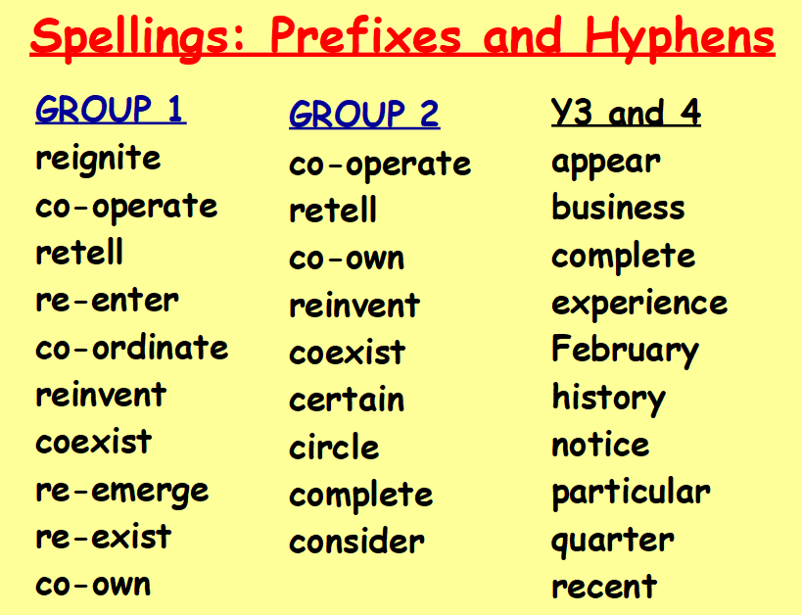

YEAR 5 SPELLINGS: GROUPS 1 *** Out on: Monday 2nd November Tested on: Monday 8th November
Look | Say | Copy in joined handwriting to build muscle memory. | Copy in joined  Handwriting NO printing. | Copy in joined handwriting NO printing |  | Write without looking | Check
co-operate
co-own |  |  |  |  | C
co-ordinate
coexist |  |  |  |  | O
re-enter
re-emerge |  |  |  |  | V
re-exist
reinvent |  |  |  |  | E
retell
reignite |  |  |  |  | R
YEAR 5 SPELLINGS: GROUPS 2 * Out on: Monday 2nd November Tested on: Monday 8th November

Look | Say | Copy in joined handwriting to build muscle memory. | Copy in joined  Handwriting NO printing. | Copy in joined handwriting NO printing |  | Write without looking | Check
co-operate
co-own |  |  |  |  | C
retell
coexist |  |  |  |  | O
reinvent
certain |  |  |  |  | V
circle
complete |  |  |  |  | E
consider
 |  |  |  |  | R

*affect – The weather will affect my plans for the weekend.
*effect – Some chemicals have a harmful effect on the environment.

