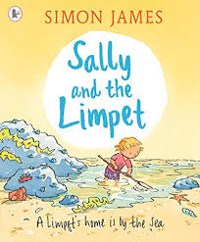
Draw a picture of a beach scene and label it.

