‘:{=
][
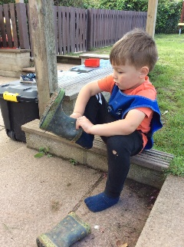
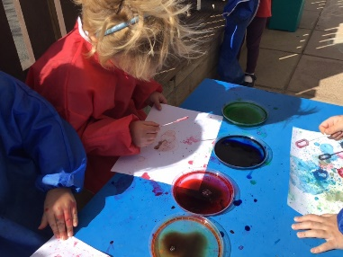
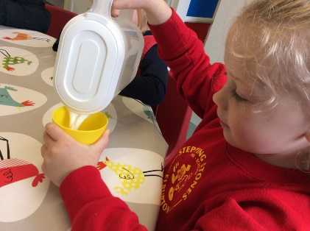
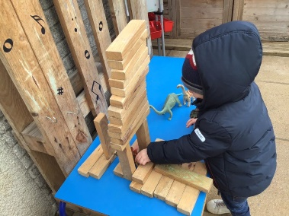
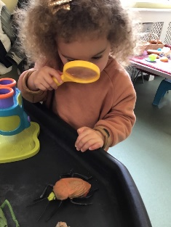
Stepping Stones Preschool - Information for Preschool Children
Staff | General information |  | Health and safety | Education/assessment
EYFS Leader  Mrs Chantal Churchill cchurchill@elburton.plymouth.sch.uk  Preschool Manager  Ms Leslie Mansfield  lmansfield@elburton.plymouth.sch.uk  Preschool Office Manager  Jo Oak | Sessions  AM 8.30 – 11.30  Lunch club 11.30 – 12.30  PM 12.30 – 3.30  Please enter through the side gate onto the patio area. | Independence  We love to foster independence in your children so we encourage them to hang up their own coats and put their belongings away. Due to the location of the pegs, please leave your child at the door – an adult will help them put their things away. | Collection  Please inform us who will be collecting your child at the end of their session. If there is any change, please inform the preschool office on (01752) 401300.  There is a late collection fee that will be enforced. | Parent’s Consultations  You will be invited to meet with the preschool staff at various times throughout the term. This has been done via zoom when needed. We can arrange a phone call with your keyworker too.  Initial assessment:  Children will complete some simple activities so we know how best to progress with their learning. | Early Years Foundation Stage Framework  We prioritise the Prime areas of learning:  Physical Development  Personal, Social and Emotional Development  Communication and Language  We also record their development in the specific areas of learning, which are:  Literacy, Maths, Understanding the World, Expressive Arts & Design
Preschool Practitioners  Karen Cassidy  Naomi Opie (SENDCo)  Naomi Allen  Sam Oakes  We also have an apprentice practitioner.  MTA for Preschool  Stacey Tasker | Breakfast Club  Preschool children can attend Breakfast club. This runs from 7.45am. Part of this from 0800 to 0830 can be included in your funding if you wish to do so.  Please contact the Preschool Office to express an interest. | Drop-In  You are regularly invited into events throughout the school year that include joining your child for activities.  These may include walks in the local area, Graduation and Sports Day. | Summer  We spend a lot of time learning outside, so in the Summer Term (and during other hot spells), every child must have sun cream applied by parents/carers before coming into Preschool.  The sun cream must provide all day protection. | Self Regulation  We encourage the children at stepping stones to begin to recognise their emotions and regulate their behaviour using stories and our characters;  Sammy Stop and Charlie Choice. | Oracy  Oracy is a focus at preschool. Oracy is the skill to be an effective communicator. We will encourage your child to be a ‘successful language learner’.  Please make the most of your conversations, tell each other about your day, listen and talk to each other. We know that life is busy but communicating is of the greatest importance.
Key Workers  Your child will be allocated a Key Worker.  We work as a team to look after the needs of all the children and they work both individually and in small groups with all the adults. | What does my child need to bring?  Book bag  Waterbottle  Spare change of clothing in bookbag  Lunch box (if applicable)  Sunhat (Summertime)  Please ensure that EVERYTHING is named. | Personal belongings  We ask that children leave their own toys at home. We can not guarantee that the toys will come back to you in the same condition as you send them.  If your child needs a dummy, please speak to your child’s key worker. | Birth Certificate  Please supply a copy of your child’s birth certificate for Government Funding Purposes. We can take a copy for you if you require us to. | Letters  The majority of the communication is sent home electronically via Parentpay.  You will also receive our newsletter, also emailed out to all parents via ParentPay. | Spare clothing  Please provide spare clothes in case your child has an accident. It can be brought into school in their bookbag along with any pull ups, nappies or wet wipes that they need. Please avoid sending in additional rucksacks as we don’t have room on their pegs.

Home/school links | Uniform and clothing | Money matters
Learning Journey  Tapestry is an online learning journal that you can access through a downloadable app. You can share the learning of your child in Stepping Stones and also add your memorable moments from home. Please complete the consent form sent via email. | Uniform/clothing  Please ensure that your child is dressed in clothes where they can move freely.  Your child will be discovering the world around them and exploring whilst at Stepping Stones. There will be a range of different experiences. Please ensure that your child is in clothing that can be easily washed.  School jumpers and cardigans  Stepping Stones Sweatshirts and T Shirts with the school logo on are available to buy online from plymouth.trutex.com or telephone them on 01752 491353 if you wish to purchase them.  Coats  Children must bring a coat every day.  Shoes  Closed shoes must be worn at all times. Strappy sandals are not suitable. Shoes should have Velcro fastenings (no laces) so children can take their shoes off and put them on independently.  Wellie Boots  We have a supply of Wellie Boots at preschool.  Name clothing:  Please ensure that all clothing, including shoes, lunch boxes, and water bottles are clearly marked with your child’s name to encourage their independence.  Book bags  Every child must have a book bag so that your child can bring their learning home from Preschool.  Bookbags are available to purchase from the Plymouth Trutex shop 01752 491353. | Important Nursery Grant Funding:  Early Years declaration forms are completed each term. Children are automatically eligible for 15 hours of funding the term after they are 3 years old.  If you wish to access 30 hours funding (15 hours more than the automatic 15hours) your application must be done online the previous term before you want the funding to start.  https://www.gov.uk/apply-30-hours-free-tax-free-childcare There is criteria to meet. If eligible, you will be given a unique code, which must be re-confirmed online every 3 months from when you first applied. It is the parent's responsibility to make sure your child’s funding status is kept up to date . We will need to know your child’s unique code so that we can process your funding. Contact Jo Oak joak@elburton.plymouth.sch.uk for more information or guidance.
Illness  Please phone the preschool office (01752 401300) if your child is absent from preschool. Children should not attend if they are ill and must be away for 48 hours following sickness/diarrhoea. If your child is still absent from Preschool you will still be charged for their missed session. |  | Hot Meals at lunchtime  Lunchtime in is the School Hall. If your child would like a school dinner, they are available a cost of £1.50.
Holidays  If you wish to take a holiday during term time, please contact the office. |  | Healthy Living Fee  We ask for a £8 contribution each term (3 terms) towards snacks, food tasting and cooking activities and other initiatives for promoting healthy living. This is payable at the start of each term and will be added to your bill.
Open door policy  We have an open door policy, if you have any questions, comments or concerns please let us know and we will arrange a time for a chat. |  | Bills/Extra Paid for Sessions  Any additional sessions your child does not usually attend will be, added to your next monthly bill. Bills come out at the beginning of the month.
Information can be found on the school’s website www.elburtonschool.com and there are regular updates on the school’s Facebook page.
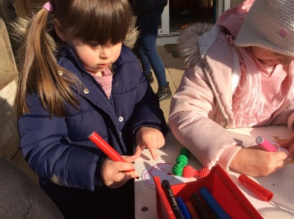
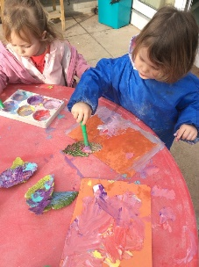
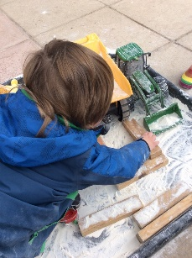
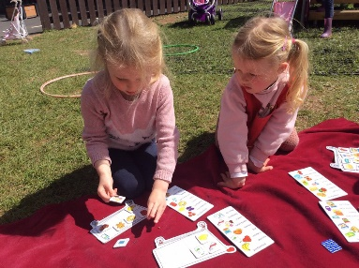
If you have any questions, please do not hesitate to contact us 01752 401300 or email steppingstones@elburton.plymouth.sch.uk

