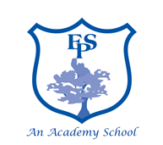

Higher Level Teaching Assistant – Elburton Primary School

28 hrs per week / 39 weeks per year Scale: Grade E
Horizon MAT are seeking to appoint a highly motivated, enthusiastic, and committed HLTA to join our dedicated foundation stage team at Elburton Primary School. The successful candidate will:
- Hold an NVQ Level 3 Teaching Assistant qualification, and/or HLTA status or relevant school based experience, or willing to work towards HLTA status.
- Have experience of, or an understanding of the Foundation Stage Curriculum.
- Be a team player with very good communication skills.
- Be committed to building and maintaining positive relationships within the school and its community.
- Have experience of whole class teaching and leading larger groups of children.
Our School is committed to safeguarding and promoting the welfare of the children. This post is subject to an Enhanced Disclosure Application to the Disclosure and Barring Service.
For full details contact Helen Sherriff email admin.elburton@elburton.plymouth.sch.uk
Closing Date: Wednesday 19th May 2021 8am Interview Date: Wednesday 26th May 2021

