**100 Books To Read In Key Stage 1**

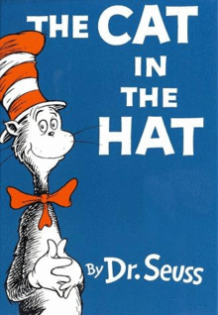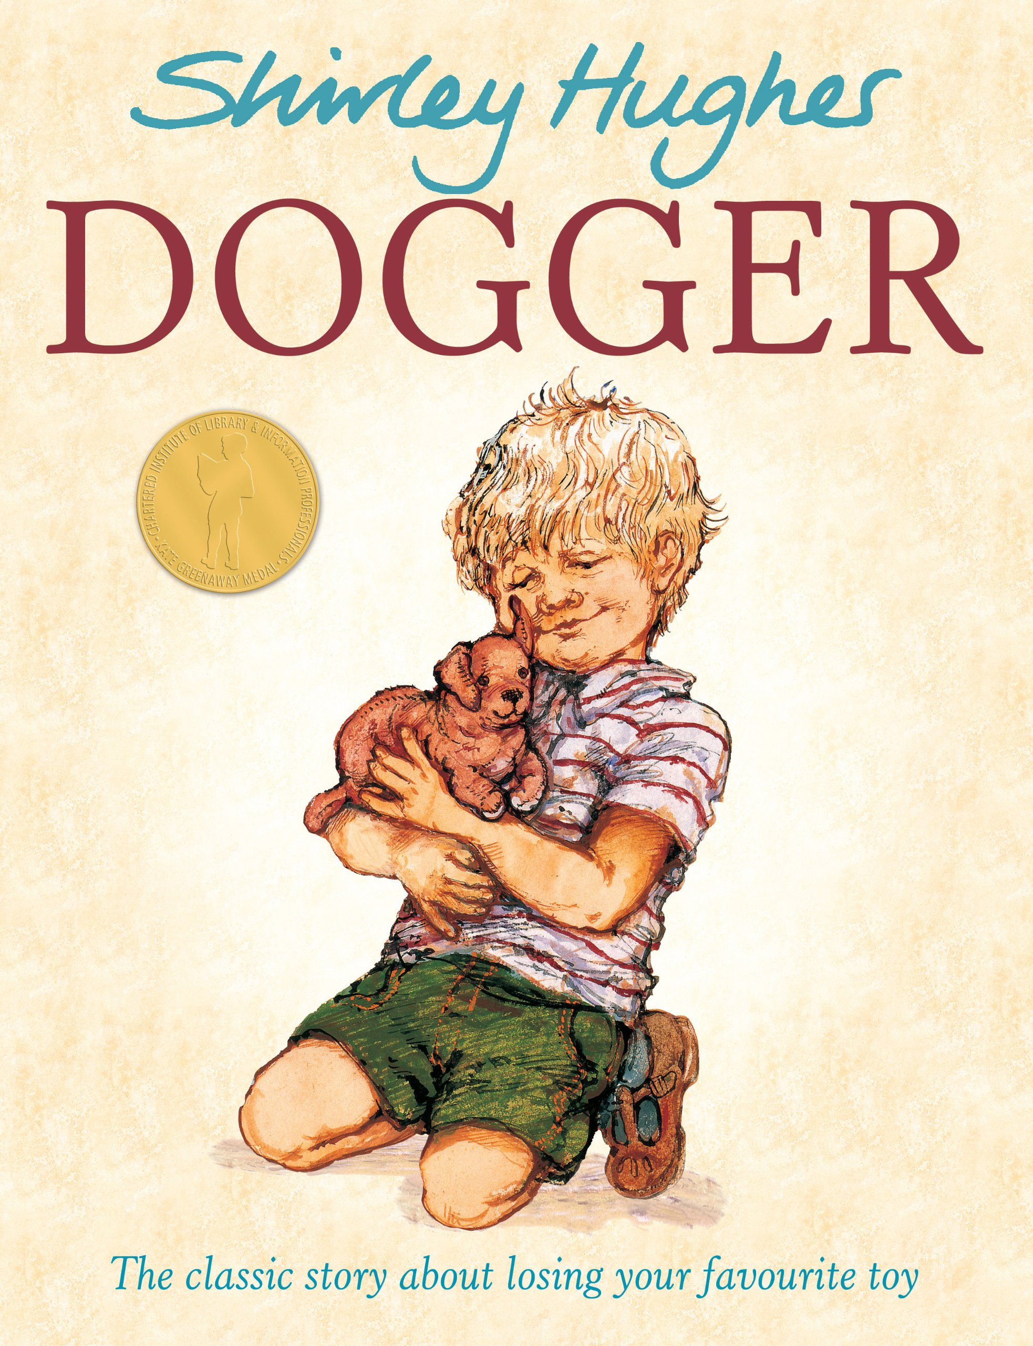

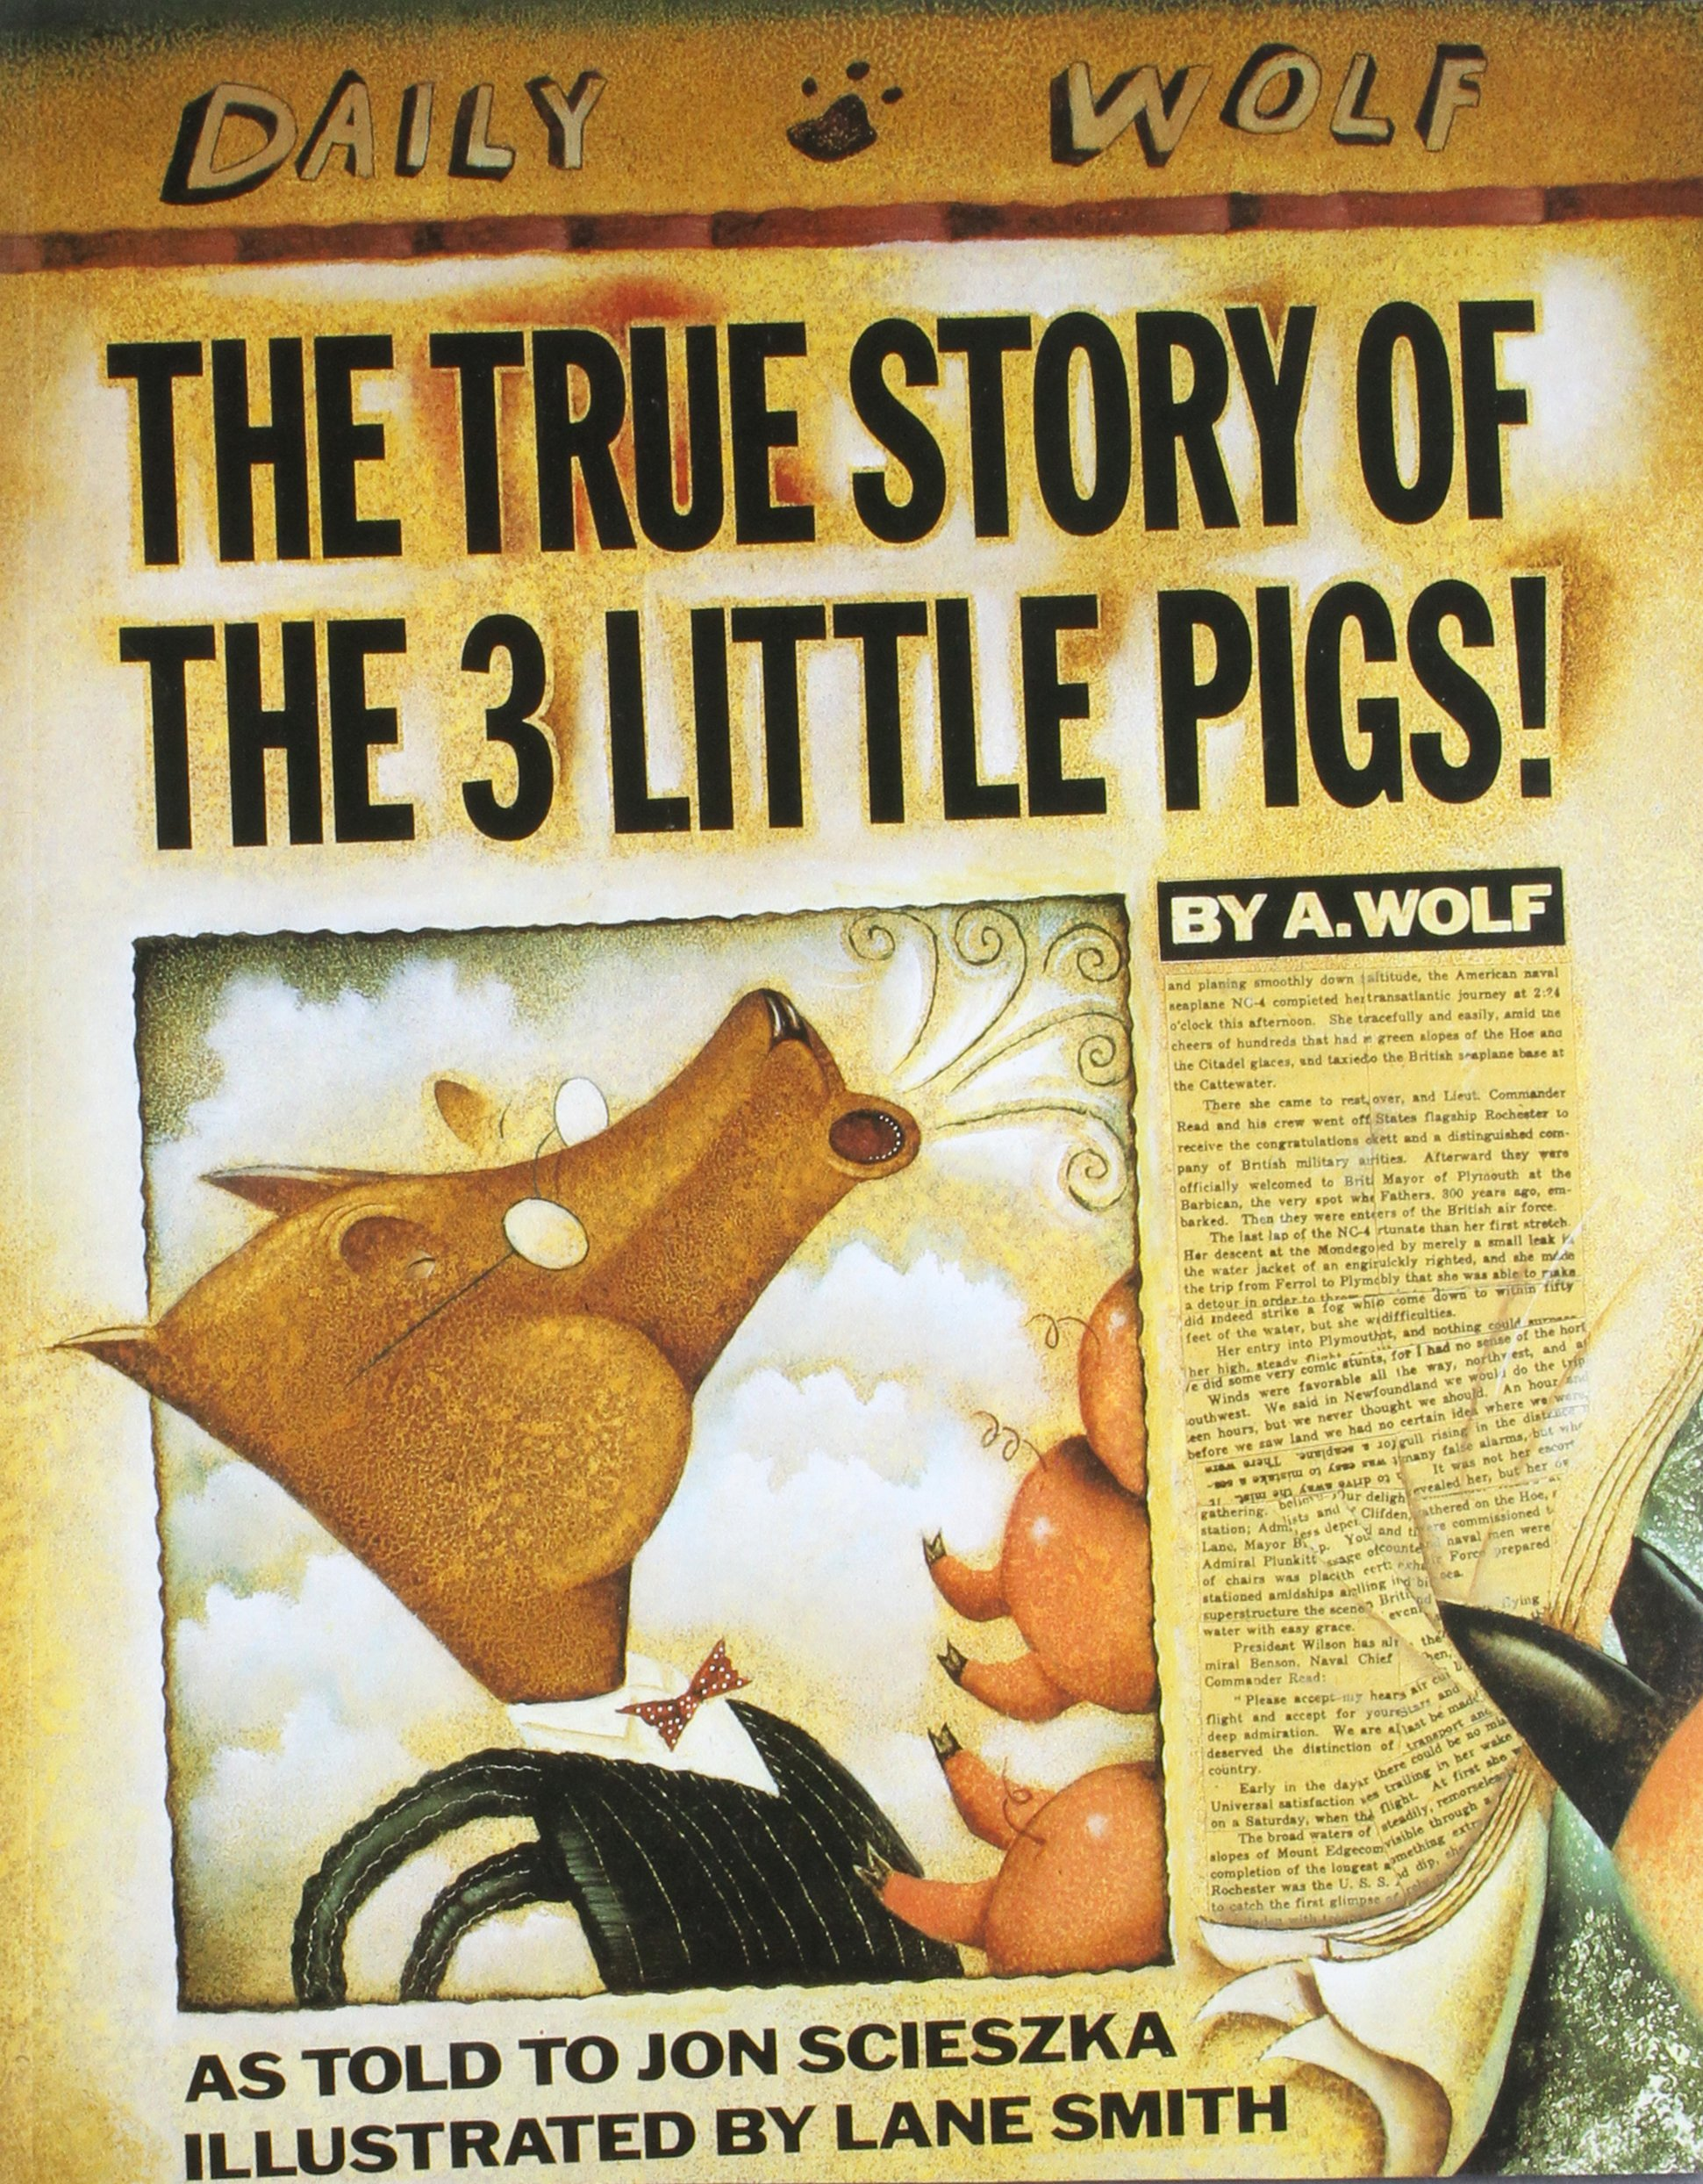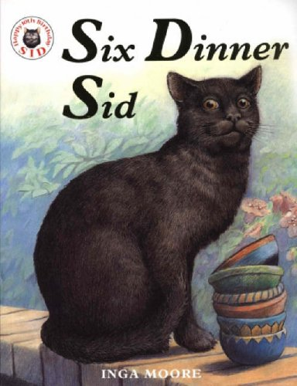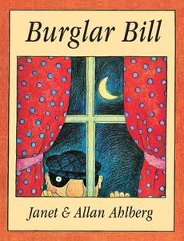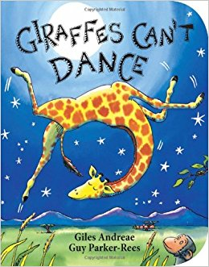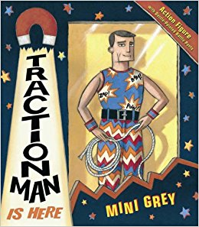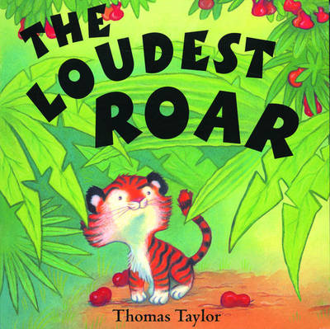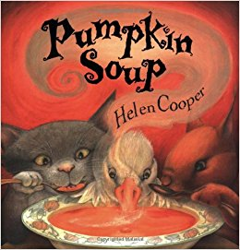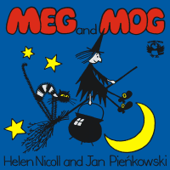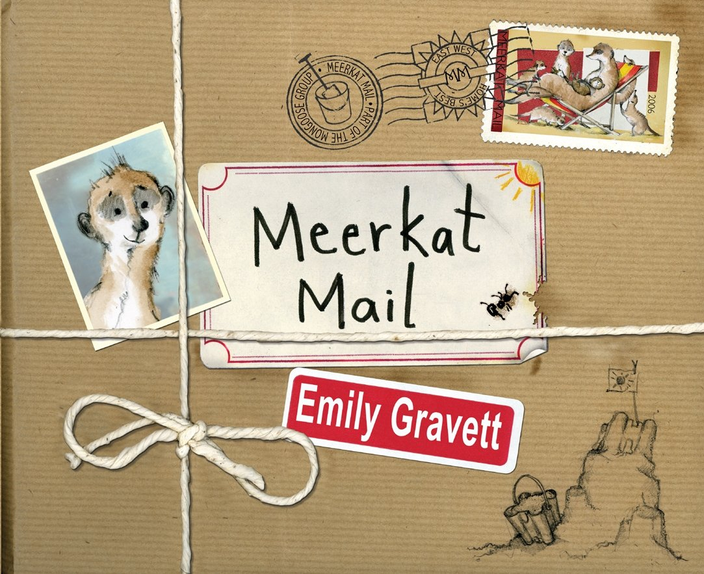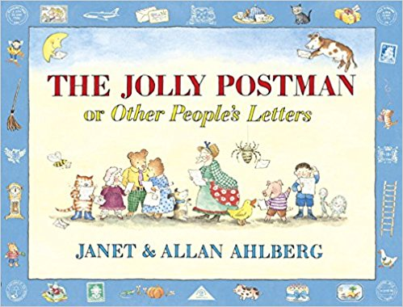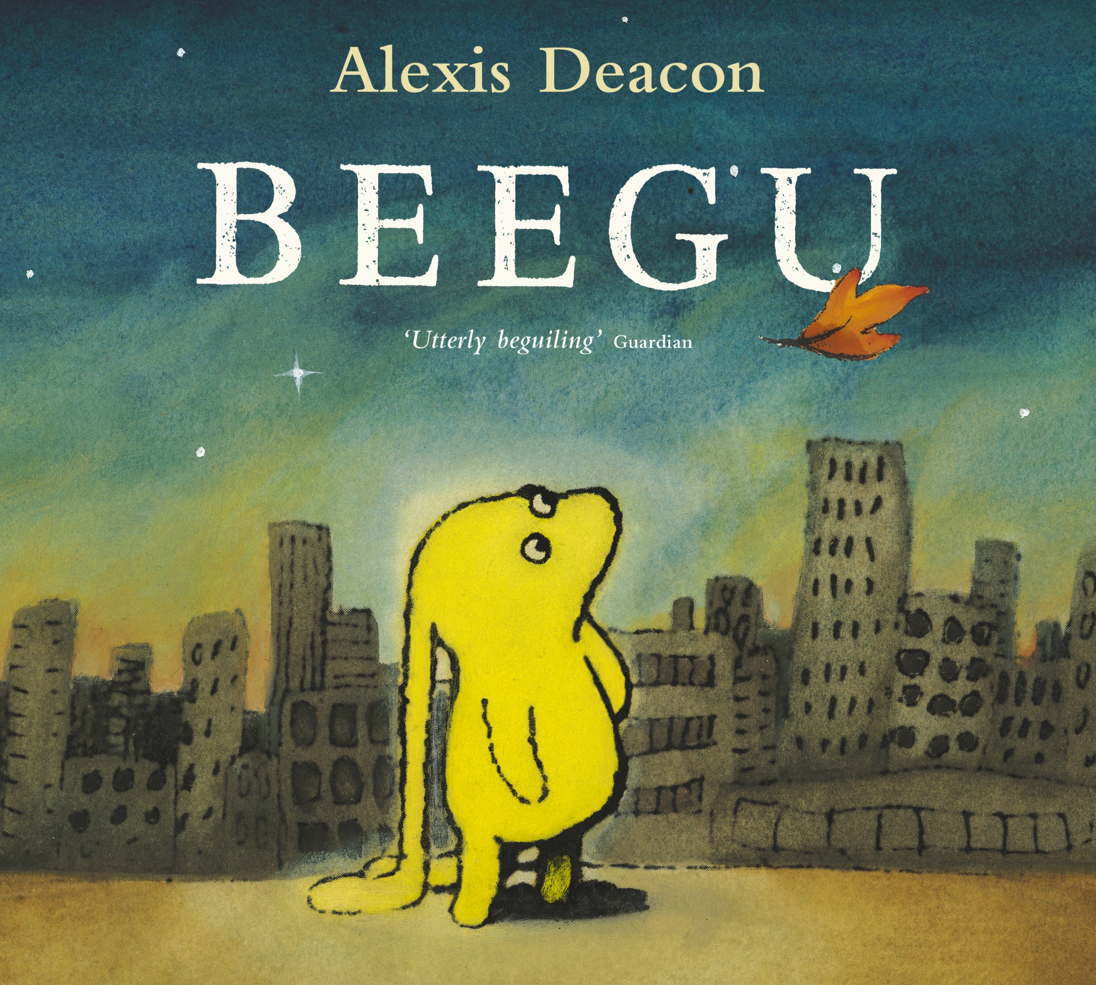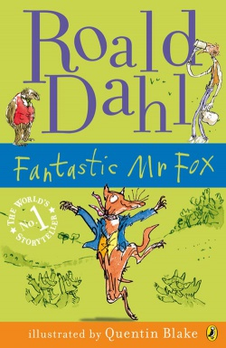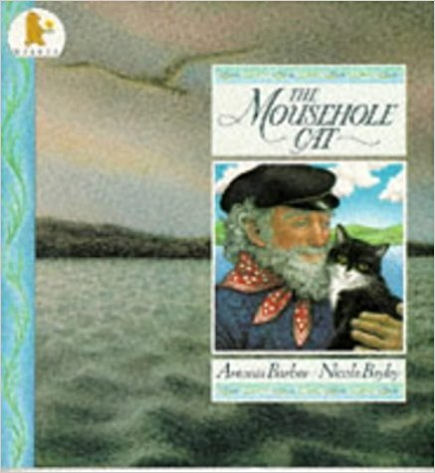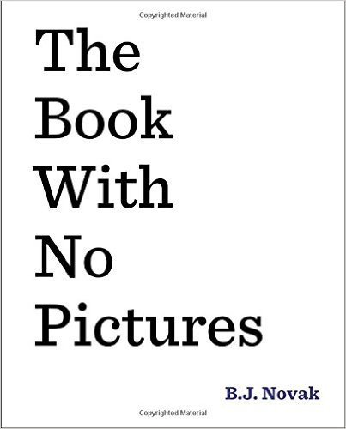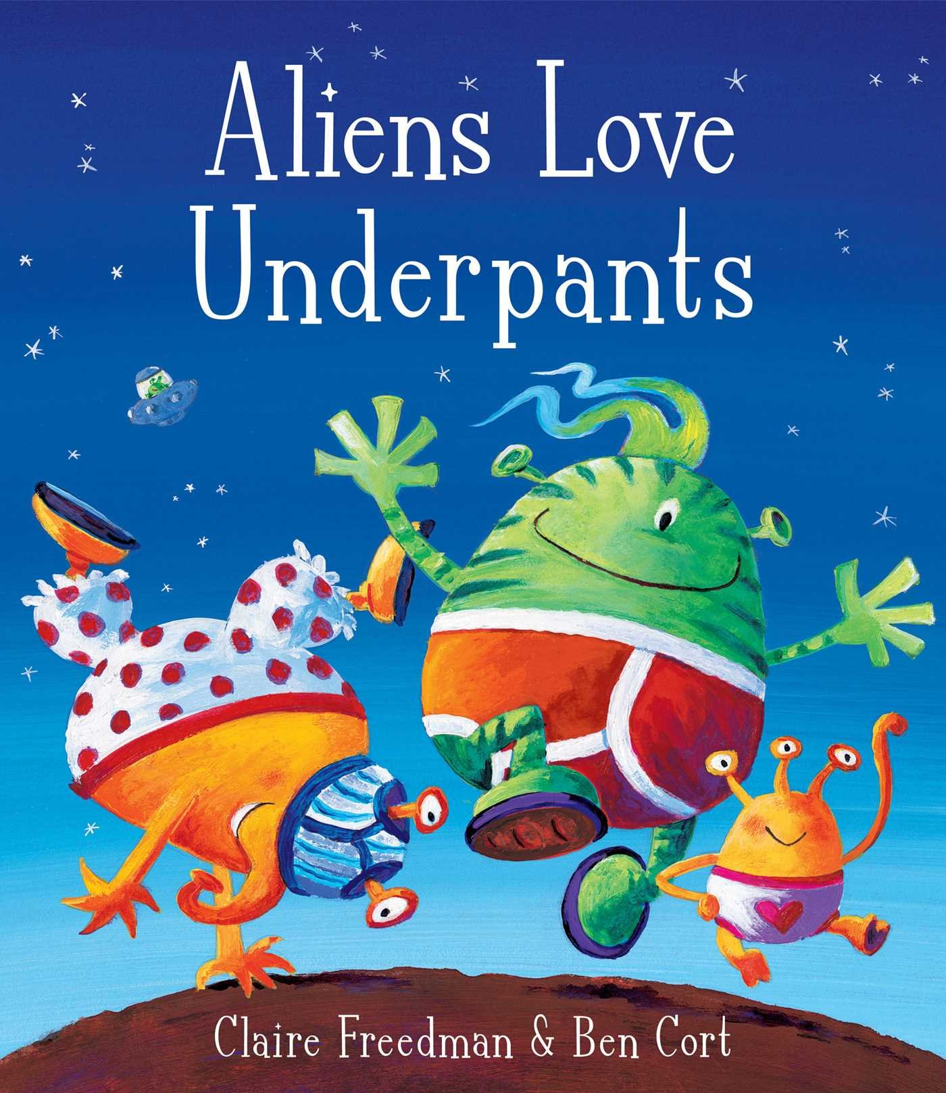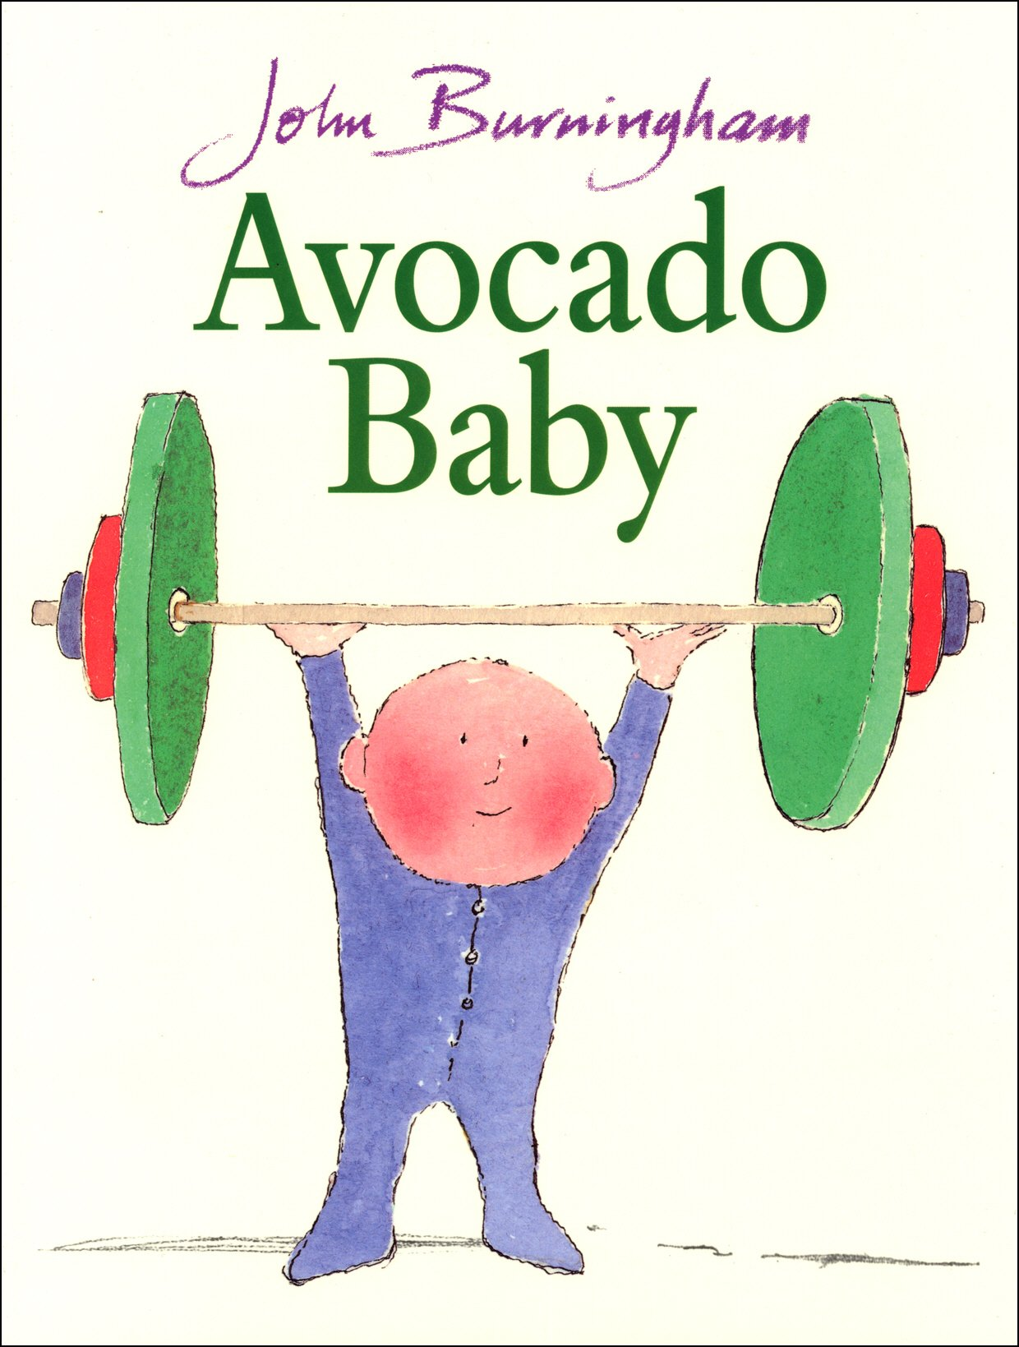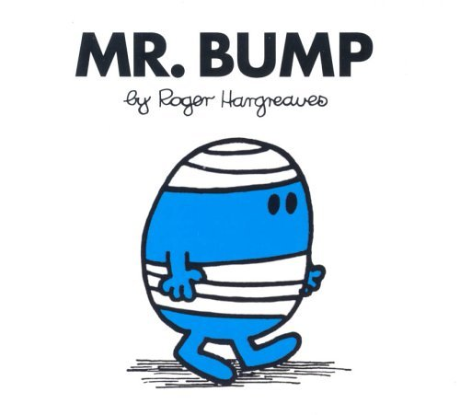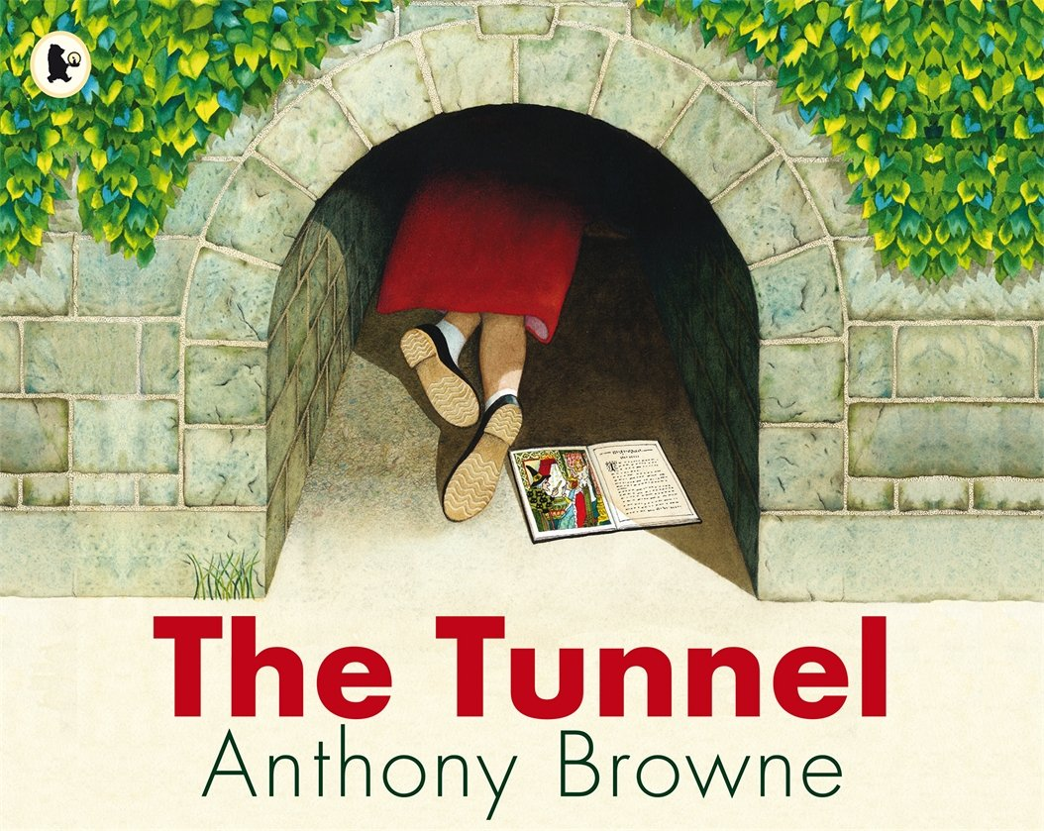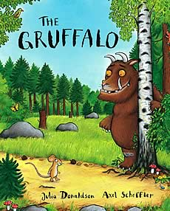

The Mousehole Cat

Antonia Barber

The Gruffalo

Julia Donaldson

The Jolly Postman

Janet and Allan Ahlberg

The Book With No Pictures

BJ Novak

The Cat In The Hat

Dr Seuss

The True Story Of The 3 Little Pigs

Jon Scieska

Six Dinner Sid

Inga Moore

Burglar Bill

Janet and Allan Ahlberg

Giraffes Can’t Dance

Giles Andrea and Guy Parker Rees

Traction Man

Mini Grey

The Loudest Roar

Thomas Taylor

Pumpkin Soup

Helen Cooper

The Tunnel

Anthony Browne

Meg and Mog

Helen Nicoll and Jan Piekowski

Meerkat Mail

Emily Gravett

Beegu

Alexis Deacon

The Fantastic Mr Fox

Roald Dahl

Aliens Love Underpants

Claire Freedman and Ben Cort

Avocado Baby

John Burningham

Mr Bump

Roger Hargreaves

Dogger

Shirley Hughes