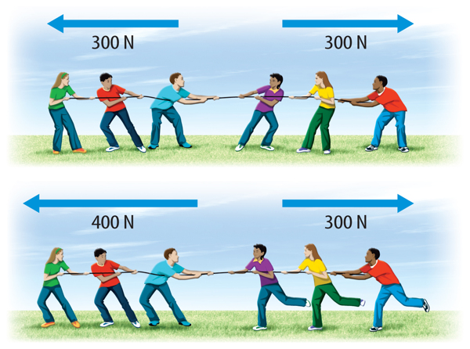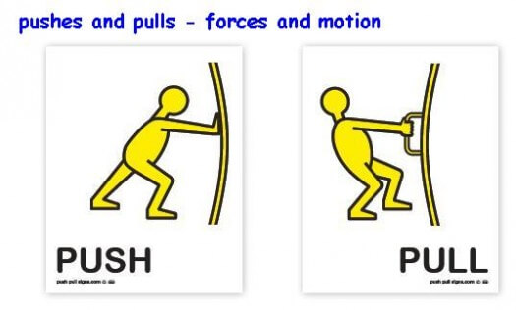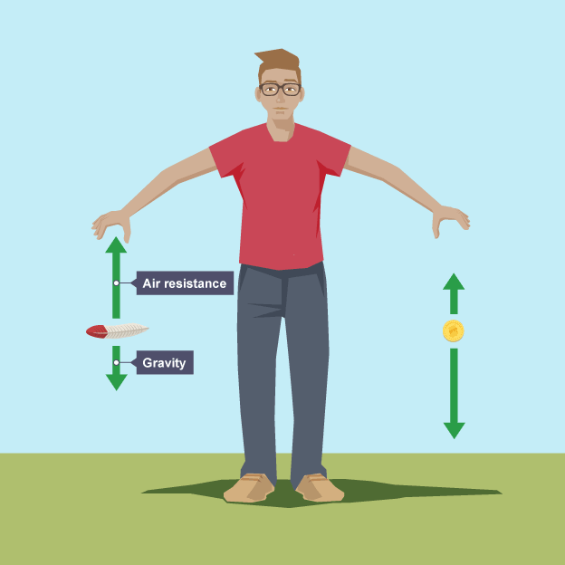

**Key Vocabulary**

**Air resistance – A force that is caused by air with the force acting in the opposite direction to an object moving through the air**

**Force – A push or pull upon an object resulting from its interaction with another object**

**Friction – The resistance that one surface or object encounters when moving over another**

**Gears – A toothed wheel that works with others to alter the relation between the speed of a driving mechanism (e.g. engine) and the speed of the driven parts (e.g. the wheels)**

**Gravity – The force that attracts a body towards the centre of the earth**

**Levers – A rigid bar resting on a pivot that is used to move a heavy or firmly fixed load**

**Mass – The weight measured by an objects acceleration under a given force or by the force exerted on it by gravity**

**Pull force – To draw or haul towards oneself or itself, in a particular direction**

**Pulleys – A wheel with a grooved rim around that changes the direction of a force applied to the cord**

**Push force – To move something in a specific way by exerting force**

**Water resistance - A force that is caused by water with the force acting in the opposite direction to an object moving through the water**

**Unbalanced Force**

**Balanced Force**

**Forces**