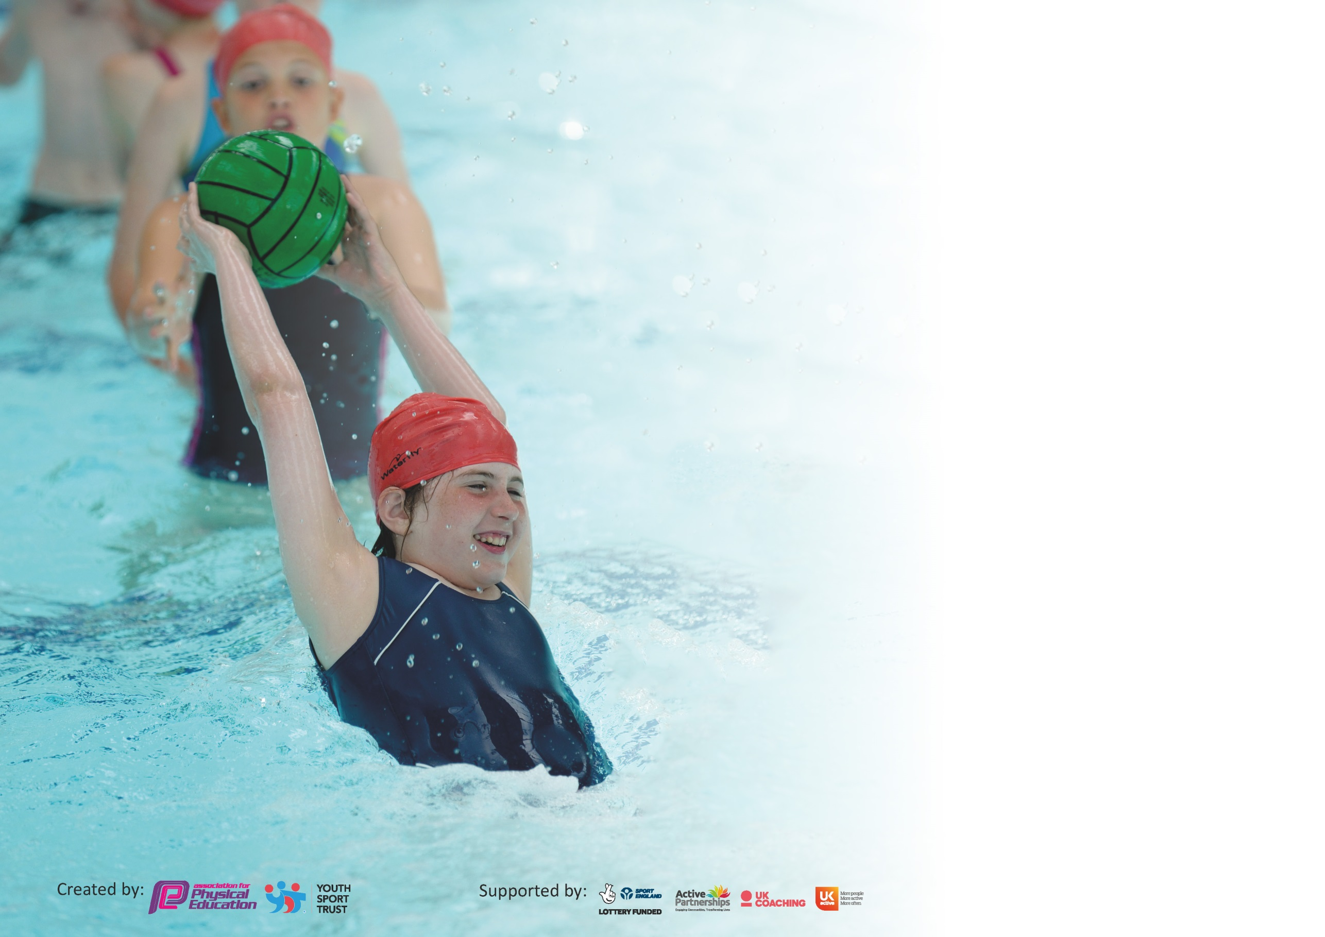

It is important that your grant is used effectively and based on school need. The Education Inspection Framework (Ofsted 2019 p64) makes clear there will be a focus on ‘whether leaders and those responsible for governors all understand their respective roles and perform these in a way that enhances the effectiveness of the school’.

Under the Quality of Education criteria (p41) inspectors consider the extent to which schools can articulate their curriculum (INTENT), construct their curriculum (IMPLEMENTATION) and demonstrate the outcomes which result (IMPACT).

To assist schools with common transferable language this template has been developed to utilise the same three headings which should make your plans easily transferable between working documents.

Schools must use the funding to make additional and sustainable improvements to the quality of Physical Education, School Sport and Physical Activity (PESSPA) they offer. This means that you should
use the Primary PE and Sport Premium to:

- Develop or add to the PESSPA activities that your school already offer
- Build capacity and capability within the school to ensure that improvements made now will benefit pupils joining the school in future years

Please visit gov.uk for the revised DfE guidance including the 5 key indicators across which schools should demonstrate an improvement. This document will help you to review your provision and to report your spend. DfE encourages schools to use this template as an effective way of meeting the reporting requirements of the Primary PE and Sport Premium.

We recommend you start by reflecting on the impact of current provision and reviewing the previous spend.

Schools are required to publish details of how they spend this funding as well as on the impact it has on pupils’ PE and sport participation and attainment by the end of the summer term or by 31st July 2020 at the latest.

We recommend regularly updating the table and publishing it on your website throughout the year. This evidences your ongoing self-evaluation of how you are using the funding to secure maximum, sustainable impact. Final copy must be posted on your website by the end of the academic year and no later than the 31st July 2020. To see an example of how to complete the table please click HERE.

Support for review and reflection - considering the 5 key indicators from DfE, what development needs are a priority for your setting and your pupils now and why? Use the space below to reflect on previous spend and key achievements and areas for development.

Key achievements to date until July 2019: | Areas for further improvement and baseline evidence of need:
2019/2020  Increased intake of after-school clubs for KS1 pupils  REAL PE training for all teachers. REAL PE is now being used as out PE curriculum from FS-Y6  2018/2019  Trained lifeguards in school to support teachers in swimming lessons  Swimming CPD for all teachers  CPD for FS and KS1 by Premier Sports  2017/2018  Gymnastics CPD for FS, KS1 and KS2 teachers  Increase in competitive Sports through level 1 and level 2 competitions  Increased intake of after-school clubs for KS1 and KS2  Platinum Kitemark Awarded October 2017 | Engaging all pupils to be active 30 minutes every day  Inspire young girls to be active and have a passion for sport  Curriculum support in the assessment of PE  ‘top-up’ sessions from Real PE coaches to support CPD  Inspire all children to improve in sports through focusing on personal best

Meeting national curriculum requirements for swimming and water safety.
What percentage of your current Year 6 cohort swim competently, confidently and proficiently over a distance of at least 25 metres?  N.B. Even though your pupils may swim in another year please report on their attainment on leaving  primary school at the end of the summer term 2020. | 96.6%
What percentage of your current Year 6 cohort use a range of strokes effectively [for example, front crawl, backstroke and breaststroke]? | 96.6%
What percentage of your current Year 6 cohort perform safe self-rescue in different water-based situations? | 100 %
Schools can choose to use the Primary PE and Sport Premium to provide additional provision for swimming but this must be for activity over and above the national curriculum requirements. Have you used it in this way? | Yes/No

Action Plan and Budget Tracking
Capture your intended annual spend against the 5 key indicators. Clarify the success criteria and evidence of impact that you intend to measure to evaluate for pupils today and for the future.

Academic Year: 2020/2021 | Total fund allocated: £19,650 (+£500 carried over from last year) | Date Updated: September 2020
Key indicator 1: The engagement of all pupils in regular physical activity – Chief Medical Officer guidelines recommend that primary school pupils undertake at least 30 minutes of physical activity a day in school |  |  |  | Percentage of total allocation:
 |  |  |  | %
Intent | Implementation |  | Impact | 39.7%
Your school focus should be clear what you want the pupils to know and be able to do and about  what they need to learn and to  consolidate through practice: | Make sure your actions to achieve are linked to your intentions: | Funding allocated: | Evidence of impact: what do pupils now know and what can they now do? What has changed?: | Sustainability and suggested next steps:
Provide Equipment Year group ‘bubble’ boxes to be used at lunchtimes, encouraging all to be more active. | - Sports Council and School council to choose equipment they would like in the boxes.  - Sports Council and School council will organise the play equipment daily.  - Create a rota/timetable. | £4000 | Increasing the number of children taking part in physical activity during lunchtimes. | New equipment will encourage pupils to play more games and be active at lunchtime.
To ensure playground equipment promotes and encourages children to be active throughout breaktimes and lunchtimes. | Reinstate the early years and KS1 playground.  School Council and Sports Council to support with the choosing of the new equipment to be instated on the playground.  The equipment will encourage children to be more physically active during break and lunchtimes. | £3,500 | All Children will have the opportunity to explore and play  Each year group will have set days and times for this and they will be encouraged by MTA’s to use it.  Teachers will make use of the new play area between lessons to increase children’s activity time (30 minutes per day outside PE curriculum time) | Increased physical exercise by all.  The trim trail has always been so widely used. Refurbishing the play areas will encourage and enthuse children to be more active in their own time.
To hire a PE MTA to work with targeted groups during lunchtime 2x weekly. | PE MTA (trained tennis coach) to organise sporting activities for selected bubbles (an alternative to Change for Life club).  - KS1 year group bubble 1x weekly  - KS2 year group bubble 1x weekly | £500 | Increasing the number of children taking part in physical activity during lunchtimes.  Improve lunchtime behaviour
Key indicator 2: The profile of PESSPA being raised across the school as a tool for whole school improvement |  |  |  | Percentage of total allocation:
 |  |  |  | %
Intent | Implementation |  | Impact | 22.8%
Your school focus should be clear what you want the pupils to know and be able to do and about  what they need to learn and to  consolidate through practice: | Make sure your actions to achieve are linked to your intentions: | Funding allocated: | Evidence of impact: what do pupils now know and what can they now do? What has changed?: | Sustainability and suggested next steps:
Time for PE leads to organize and manage PE throughout the school  A broad and balanced PE curriculum/engagement in various levels of competition/celebration of participation. | - Write comprehensive development plans.  - Monitor the planning, delivery and assessment of PE  - Organise CPD  - Maintain the School Games Mark expectations and collate all necessary evidence  - Liaise with KS1 PE co-ordinator and PE Apprentice | £600 for 6 mornings | - Improving the quality of the PE experience of students  - Development plans  - Lesson observation and feedback notes  - Programme of CPD opportunities  - School Games Mark Evidence and Award | Knowledge and experience of PE lead will ensure that we are able to maintain comprehensive action plans, re-use existing formats for vital documents and templates for letters home etc.
- Hire a PE Apprentice to support the development and provision of PE and sports. | - Support teachers for PE and games in the afternoons. Work with targeted children on Fundamentals and ABC’s.  - Support PE Co-ordinator:  -Auditing and organising equipment  -Evidencing for Kitemark, e.g. displays, photographs, social media etc.  - Run a club during lunchtimes (possibly change for life club - this may need to be in year group bubbles, half termly)  - Support staff organising events and attend some of the PSSP events. | £3000 | - Improving the quality of the PE experience of students  - School Games Mark Evidence and Award  - Change for Life club that is sustainable  - Increase participation in Level 2 events; attend more Level 2 events | Apprentice will support increase in participation of level 2 competition as he will be able to attend the events.
- Hire an admin assistant to be responsible for the organisation of letters and registers for sporting clubs and events | - Support PE lead in writing letters for clubs  - Support PE lead with admin for level 2 and 3 competitions  - Collate registers to track participation and for parent pay for any clubs | £1000 | - Improving the organization of PE in line with OfSTED and school gamesmark  - School Games Mark Evidence and Award  - Track and increase participation in Level 2 events; attend more Level 2 events | An admin assistant will help to monitor the participation of after-school clubs and level 2 competitions. All information will be kept centrally on ParentPay.

Key indicator 3: Increased confidence, knowledge and skills of all staff in teaching PE and sport |  |  |  | Percentage of total allocation:
 |  |  |  | %
Intent | Implementation |  | Impact | 19.85%
Your school focus should be clear | Make sure your actions to | Funding | Evidence of impact: what do | Sustainability and suggested
what you want the pupils to know | achieve are linked to your | allocated: | pupils now know and what | next steps:
and be able to do and about | intentions: |  | can they now do? What has
what they need to learn and to |  |  | changed?:
consolidate through practice:
Positively impact learning in PE | - PSSP employed to deliver bespoke CPD sessions for KS2 teachers.  - Attend primary PE conference and access regular INSET’s provided. | £3500 | Continued professional development for PE lead as well as wider school staff. Up-to-date relevant resources employed by staff to deliver PE.  Increased confidence levels will positively impact teaching and learning | Investing in staff is a priority as this will be our most sustainable resource. Staff confidence and knowledge will benefit all children in years to come. Continued affiliation with the PSSP will mean that we can access ongoing CPD and support.
Positively impact learning in PE | - Hire Real PE coaches to support staff CPD  - Staff to team teach alongside experienced REAL PE coaches  - Real PE coaches to support how assessment it used through the curriculum | £500 | Increased confidence levels will positively impact teaching and learning
Key indicator 4: Broader experience of a range of sports and activities offered to all pupils |  |  |  | Percentage of total allocation:
 |  |  |  | %
Intent | Implementation |  | Impact | 14.8%
Your school focus should be clear | Make sure your actions to | Funding | Evidence of impact: what do | Sustainability and suggested
what you want the pupils to know | achieve are linked to your | allocated: | pupils now know and what | next steps:
and be able to do and about | intentions: |  | can they now do? What has
what they need to learn and to |  |  | changed?:
consolidate through practice:
Continue to introduce new sports activities encouraging more pupils to take up to be involved in physical activity | Premier Sports after-school club for KS1 and KS2  - Offer multi-sports clubs to KS1 to promote a wide range of sports, encouraging children to keep active and inspire them for lifelong physical activity.  - KS2 offer of alternative sports, such as fencing and ultimate Frisbee. | £116 per week = approximately £3000 - £3500  (dependent on parental support – payment of £3 per session) | Increasing participation in after school activities to year groups who in the past were not able to participate | Display of clubs available to pupils in area  Celebrate participation in sport through whole school assembly presentations.  Increased participation for KS1 pupils for first half of year.  Premier Sports worked with Educare pupils weekly during school closures.
To ensure PE resources provide impact on learning | PE equipment  Purchase new equipment for Year group bubbles to be used for REAL PE curriculum as well as lunchtime activities. | *See KI1 | Staff can teach the curriculum with the necessary resources, and inspire children with new equipment/games.

Key indicator 5: Increased participation in competitive sport |  |  |  | Percentage of total allocation:
 |  |  |  | %
Intent | Implementation |  | Impact
Your school focus should be clear | Make sure your actions to | Funding | Evidence of impact: what do | Sustainability and suggested
what you want the pupils to know | achieve are linked to your | allocated: | pupils now know and what | next steps:
and be able to do and about | intentions: |  | can they now do? What has
what they need to learn and to |  |  | changed?:
consolidate through practice:
Increase the number of competitive opportunities for children of all abilities and age groups. | Annual membership to the PSSP: target events offered by the PSSP to provide children of all age groups and abilities with the opportunity to compete. | *PSSP cost in KI3 | PSSP provide termly reports on the number of events attended. PE Coordinator will monitor engagement of all children throughout the year. | Continued affiliation to the PSSP will ensure we are able to access a broad range of events and competitions. Positive experiences will likely lead to life-long participants.
After-school clubs with Premier sport 2x weekly to promote healthy competition. | Premier Sports after-school club for KS1 and KS2, promoting a range of sporting activities and healthy competition. | *See KI4 |  | Display of clubs available to pupils in area  Celebrate participation in sport through whole school assembly presentations.
To provide children with the opportunity to build confidence in swimming | Hire a swimming Life guard 2x weekly for after-school club.  Ensure currently lifeguards have up-to-date training/train more life guards to support teachers in swimming lessons? | £500 | Additional swimming sessions will give children the opportunity to build their confidence and enjoyment.  This did not take place due to school closures. | Not needed due to school closure (used to cover Premier Sports additional costs as there were no parental costs during the school closure).  Staff will need to be retrained next year.

Signed off by
Head Teacher:
Date:
Subject Leader:
Date:
Governor:
Date:

