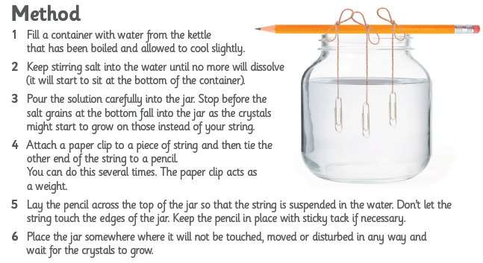
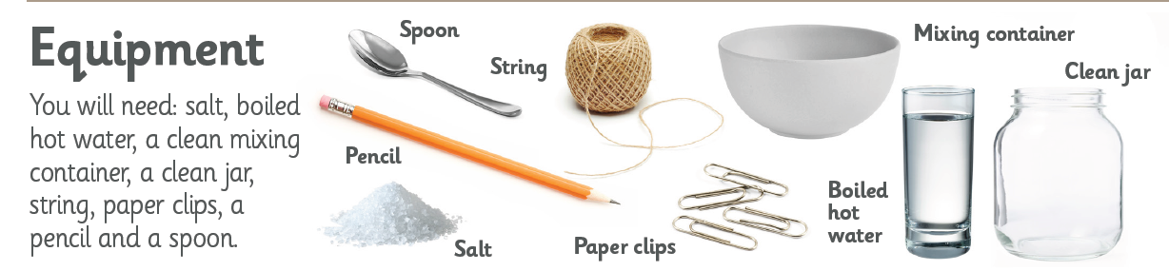
Grow your own salt crystals
Challenge
Try using different salts to produce different crystals. E.g. What is the difference between table salt and Epson salt crystals?
How can you alter your designs?

